**Exercise 3**

**R $\ddot{o}$ ssler oscillator**

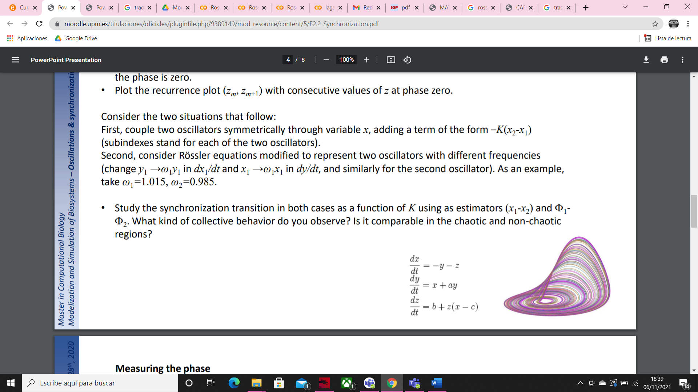

In this equation, a, b and c are parameters, and x, y and z are variables which evolves over time. the first two equations have linear terms that create oscillations in the variable x and y. The last equation has one nonlinear term (xz) so the expected chaotic behavior is appeared thanks to this term.

In those examples we fix a = 0.2, b =0.3 and we change c parameter between 3, 4, 4.5 and 5.2.

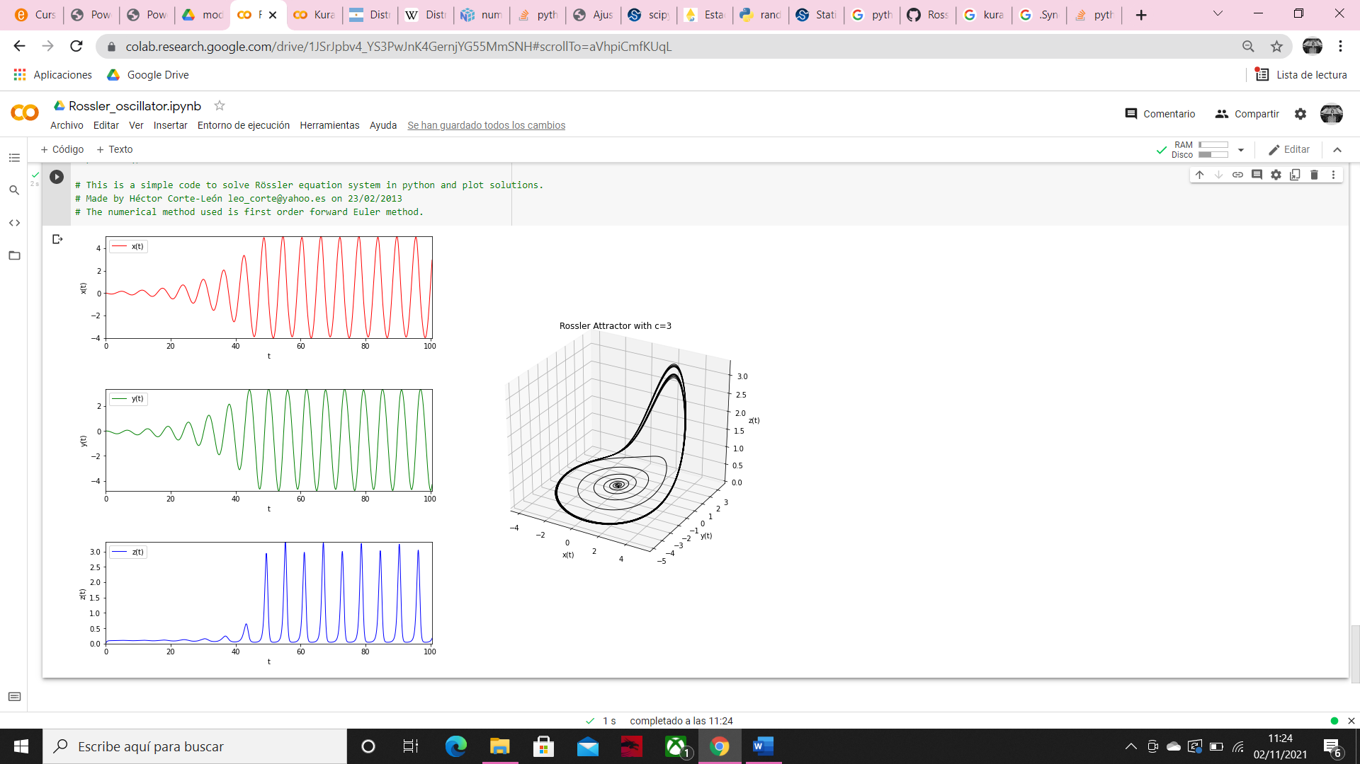

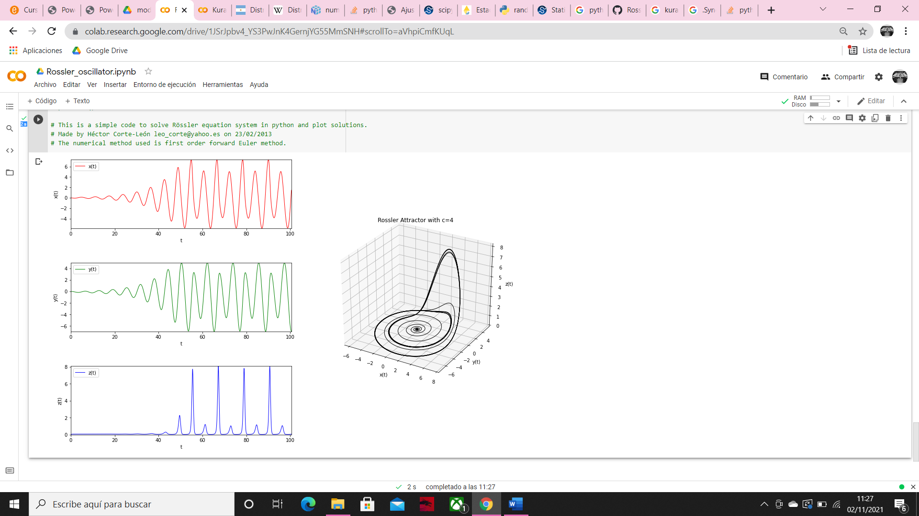

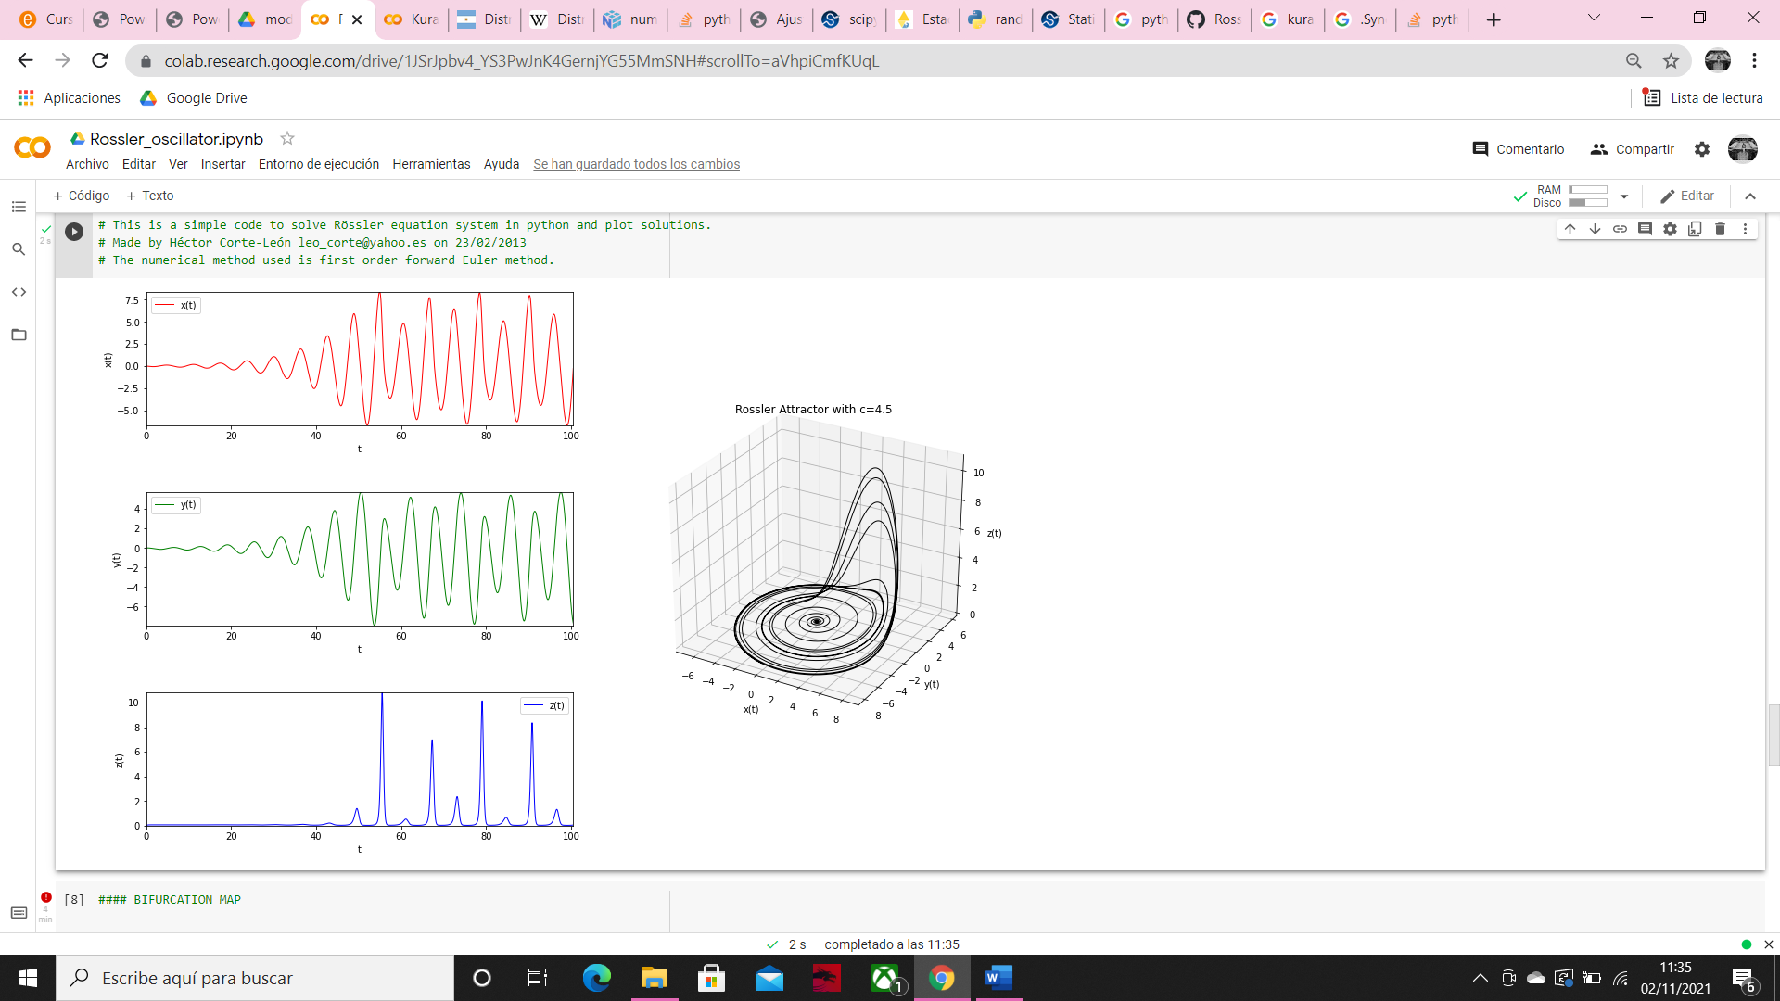

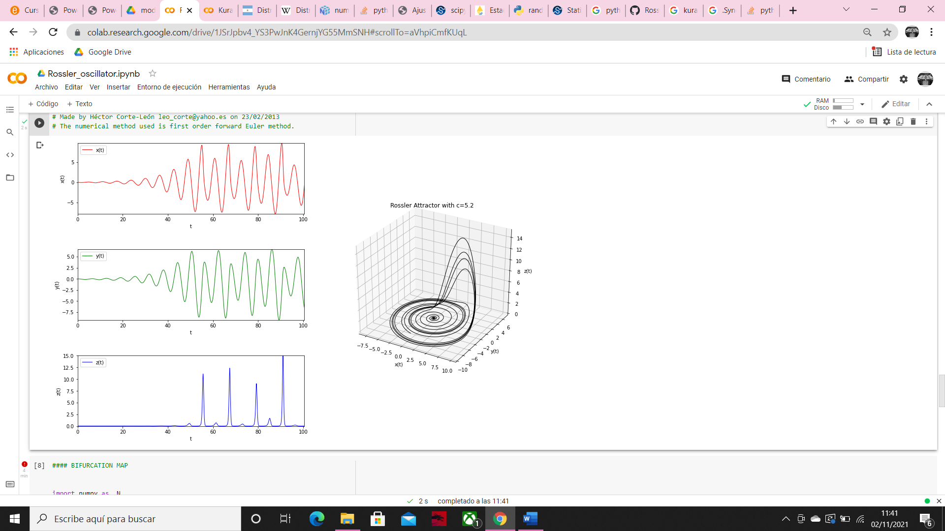

Here we can see how in the first case the three variables are more similar, but when we increase c, x and y became more irregular and z is really affected, with the duplication of its period.

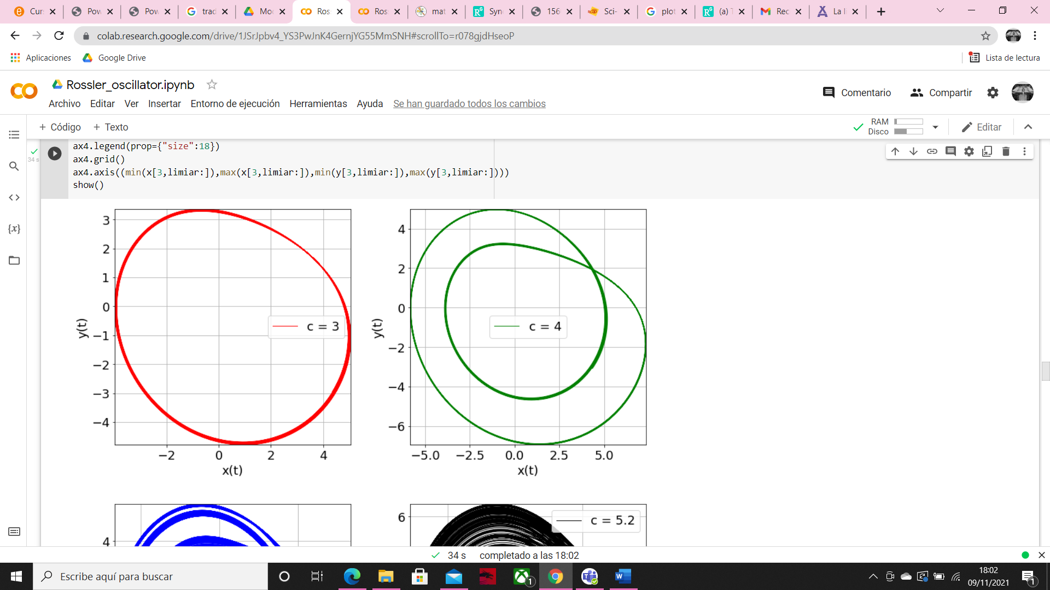

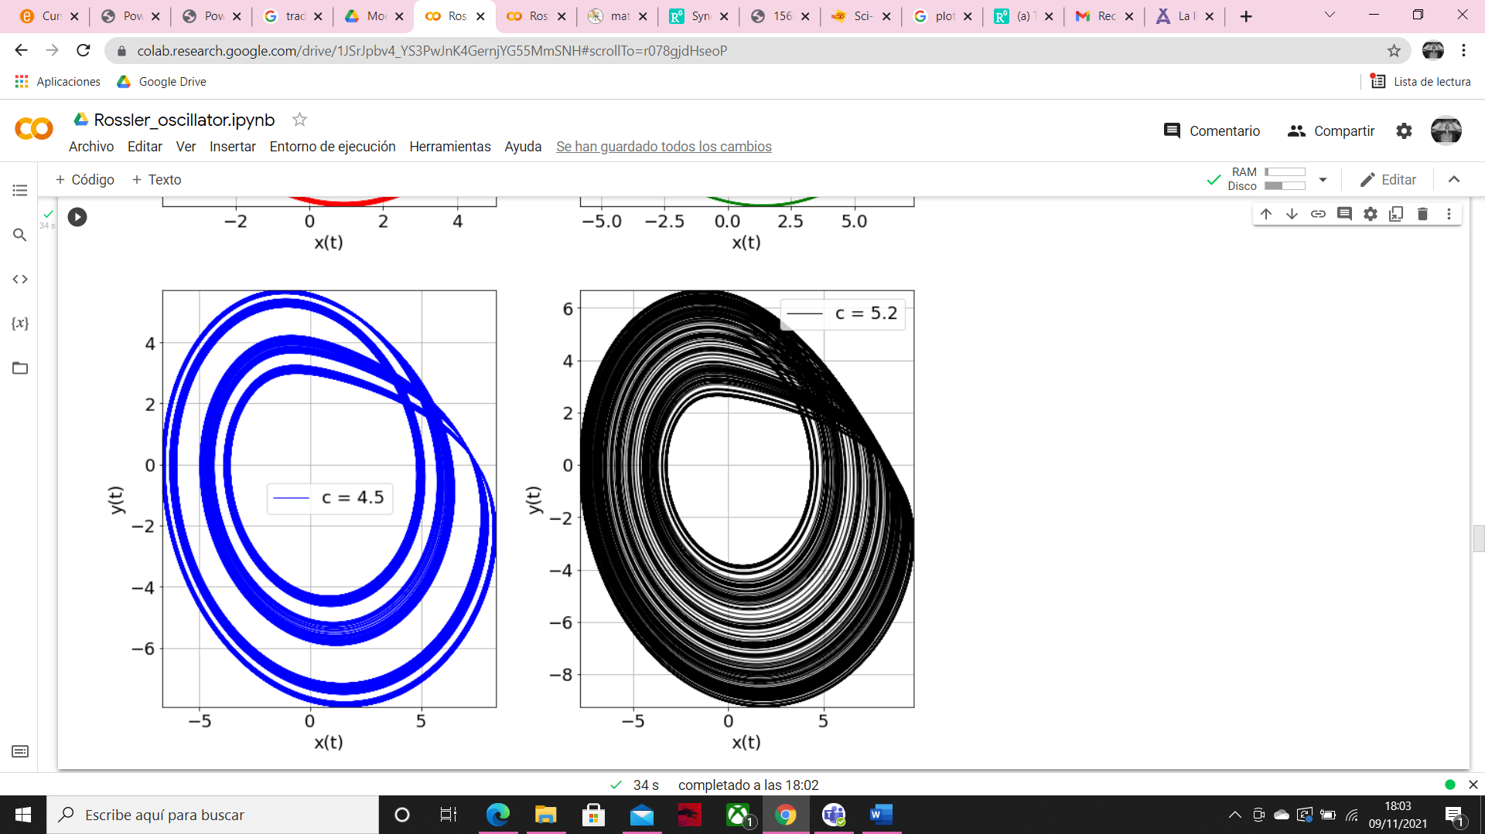

In those graphics 2D we can see in the first case, with c=3 an orbit of period one, with c=4 an orbit with period 2, with = 4.5 an orbit with period 4. When c=5.2 we reach a chaotic behavior.

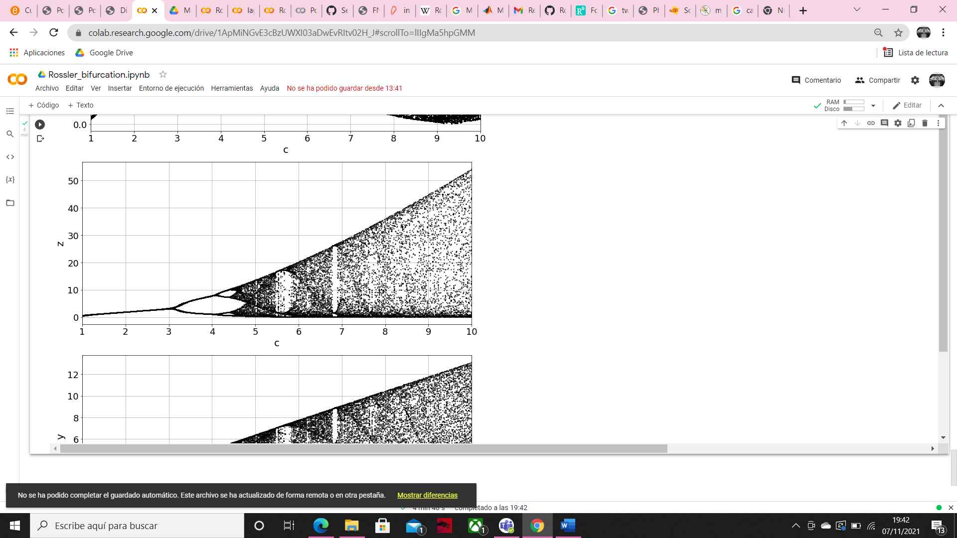

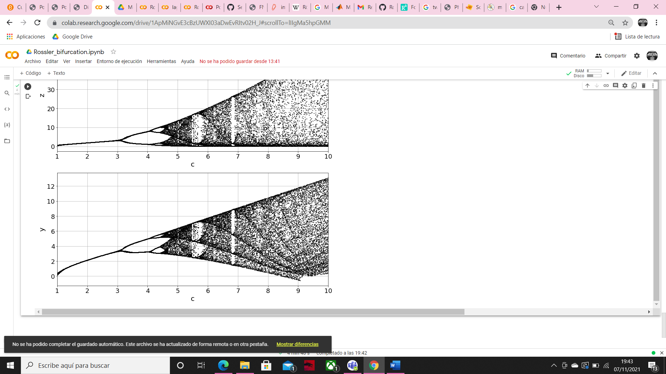

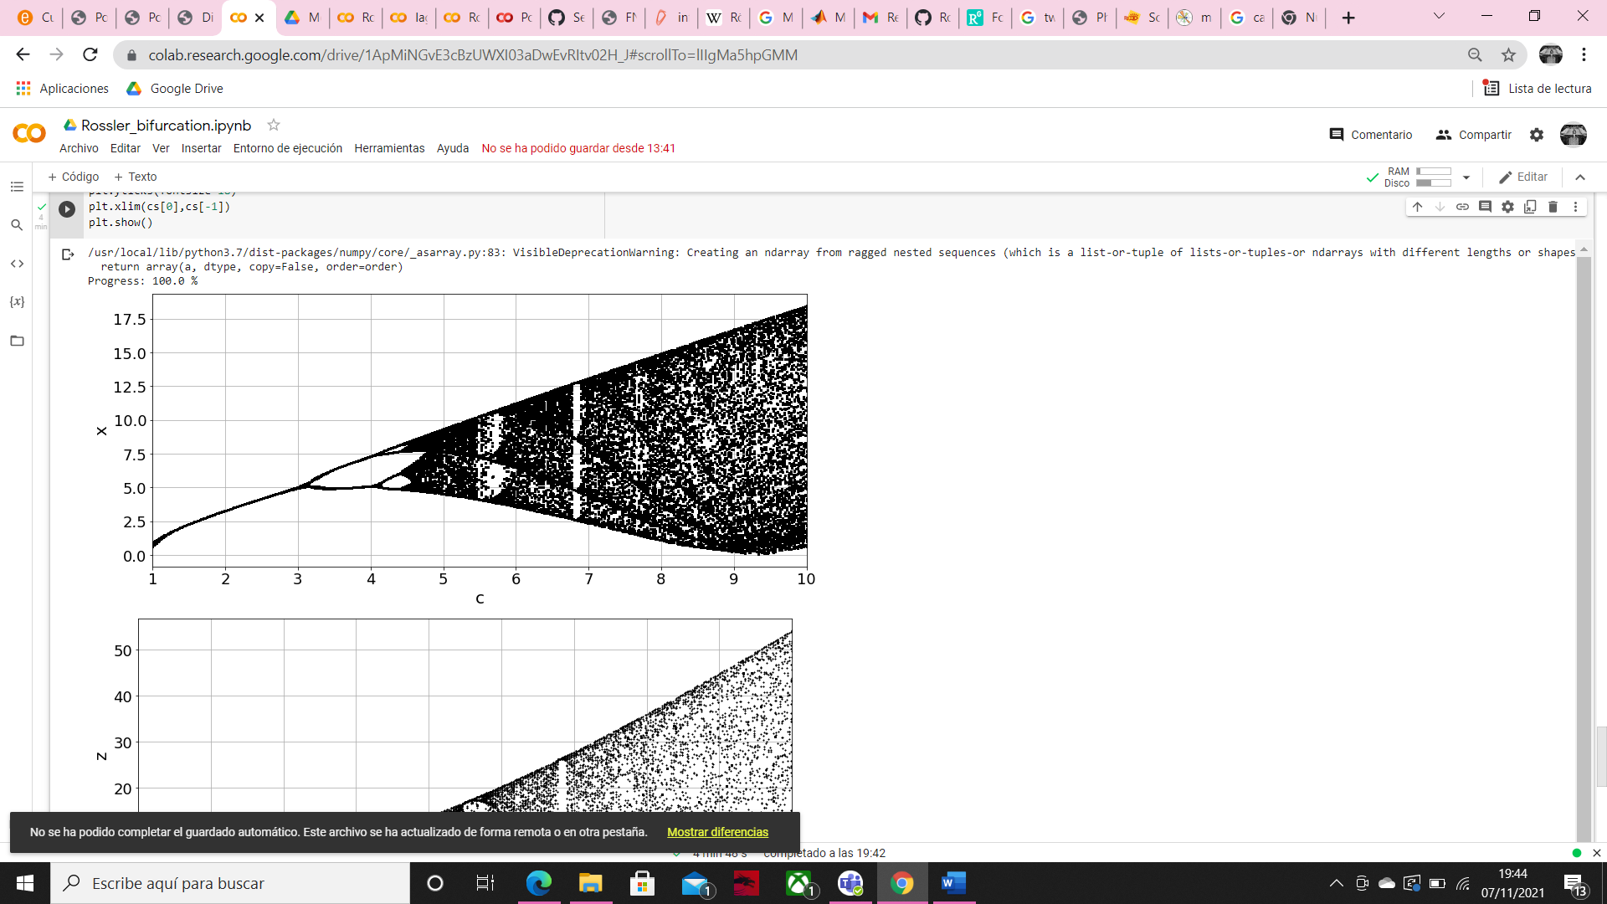

Thanks to those bifurcation diagrams we can see how as we saw before when c = 3 we have only one line, which agrees with the orbit with a single period of the previous graph, with c = 4 we can see a bifurcation (period 2), with c=4.5 two bifurcations (period 4) very close to chaos, and finally with c = 5.2 we have chaos. Morover we can see, how the behavoir is similar in the three variables. Those zones that are white in the chaotic region, are periodic windows.

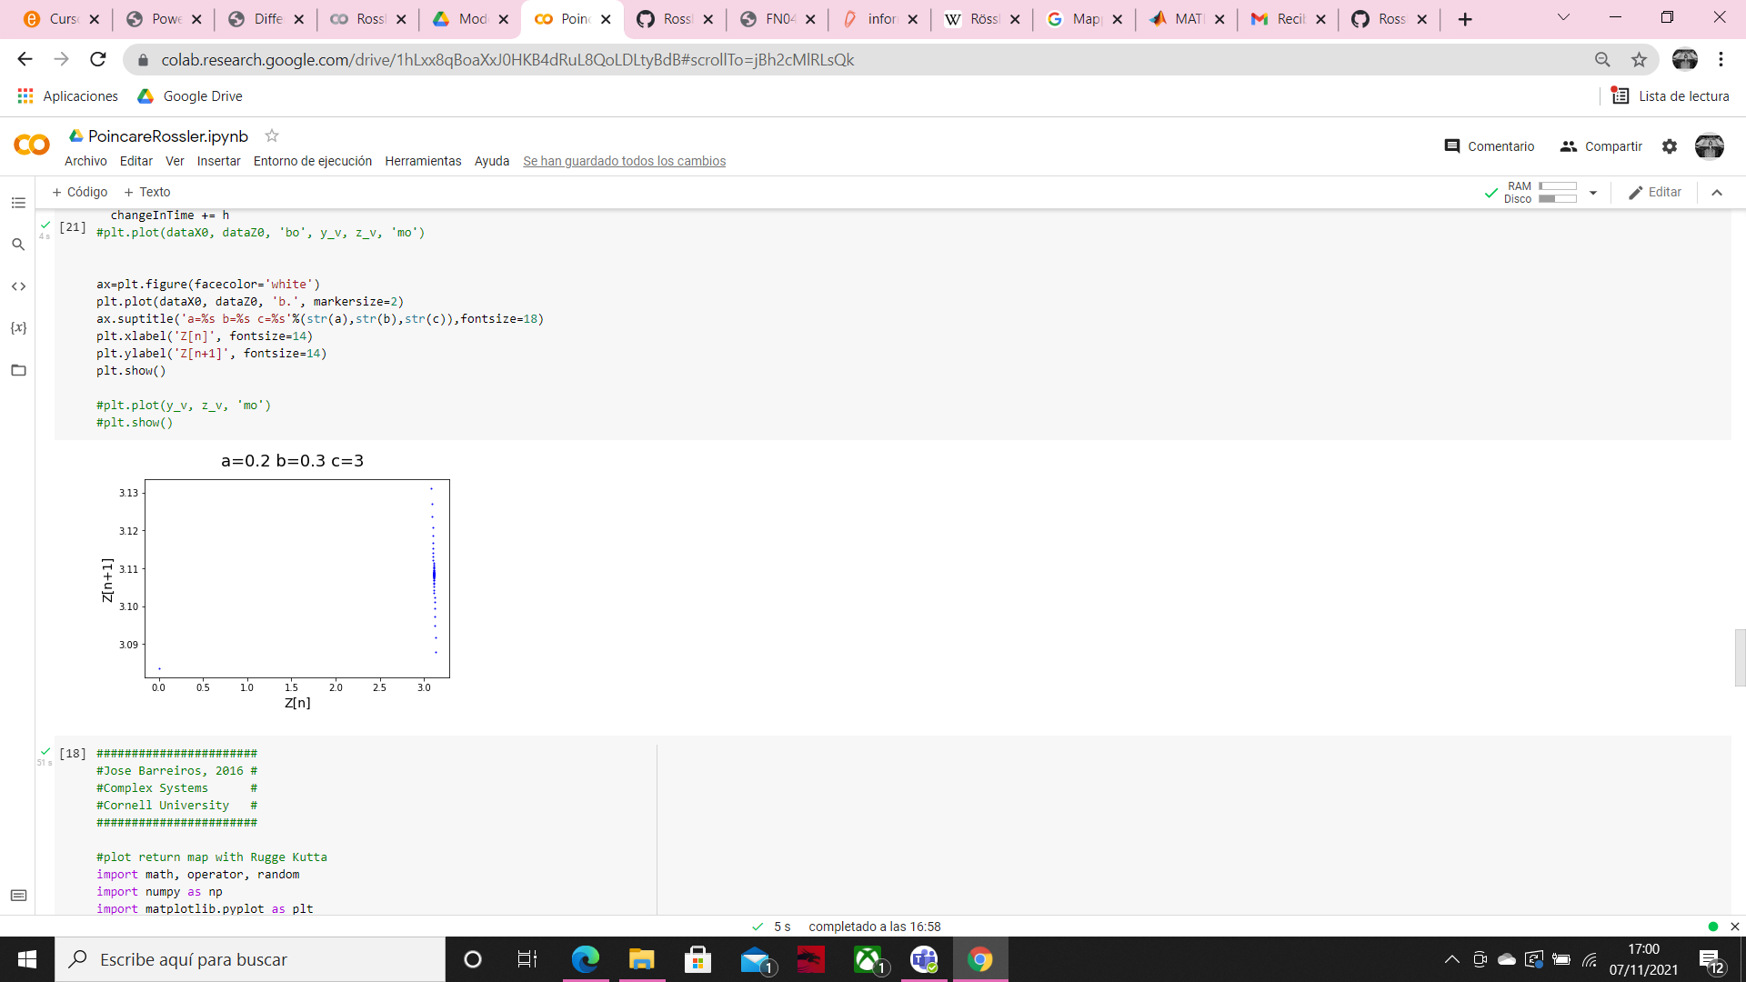

With those parameters the maximum values of variable z are very close to 3, as we can see in the graphs above.

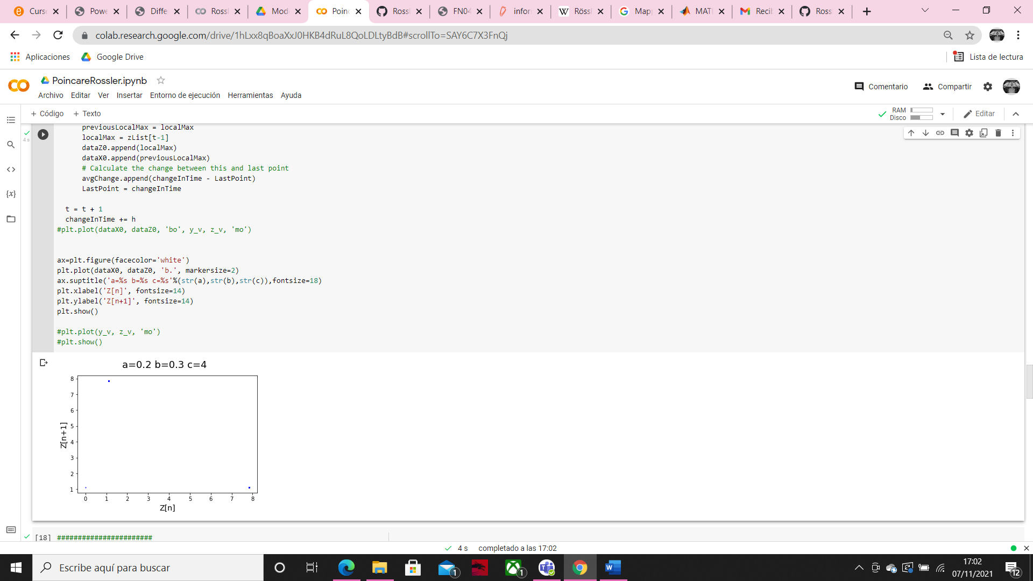

This graph is telling us that with this conditions z have at the beginning has a maximum value close to one, and the next maximum value is close to 8, so the maximum points are going to oscillate between these two points (1-8).

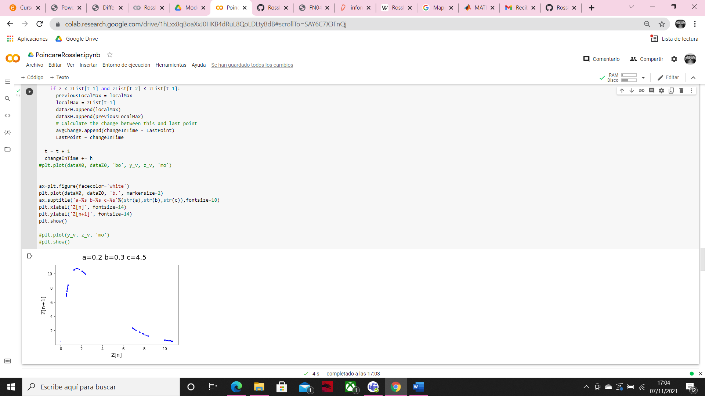

With c=4.5 we can see that z have 4 different zones where the z maximum values are going to oscillate, but unlike in the previous case we don’t have just one point, we have a range of values in each zone.

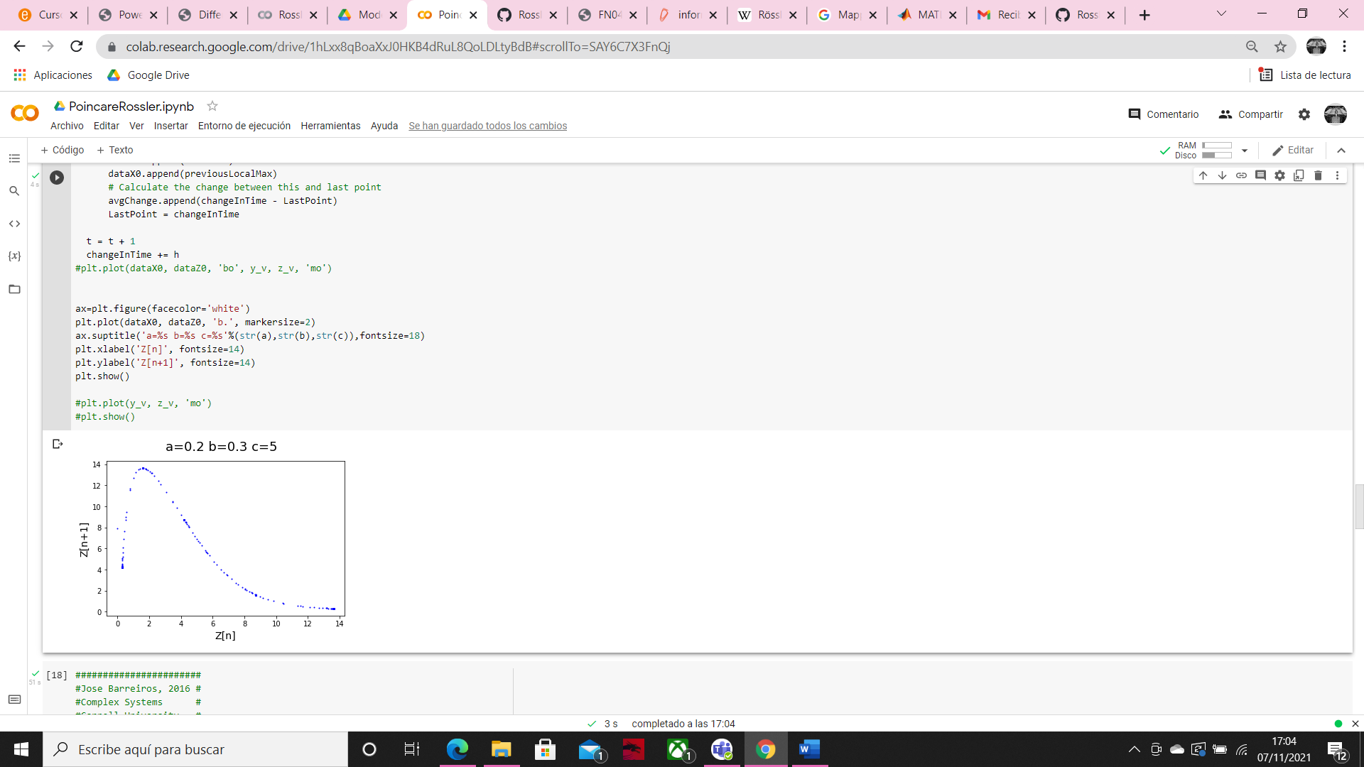

Finally, with c=5 the maximum values of z don’t have any “attractor” zone they vary across the range (chaos).

**First situation**

Those graphics are generated with k = 0.1, c=3

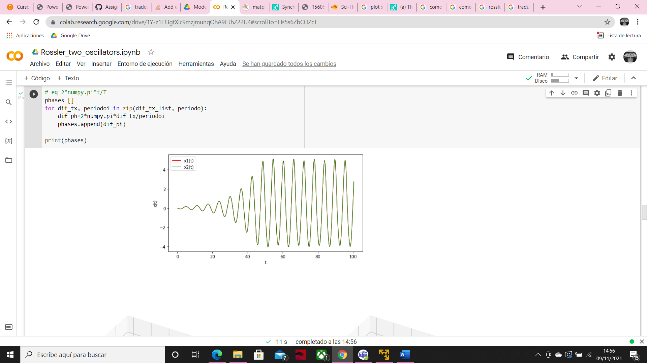

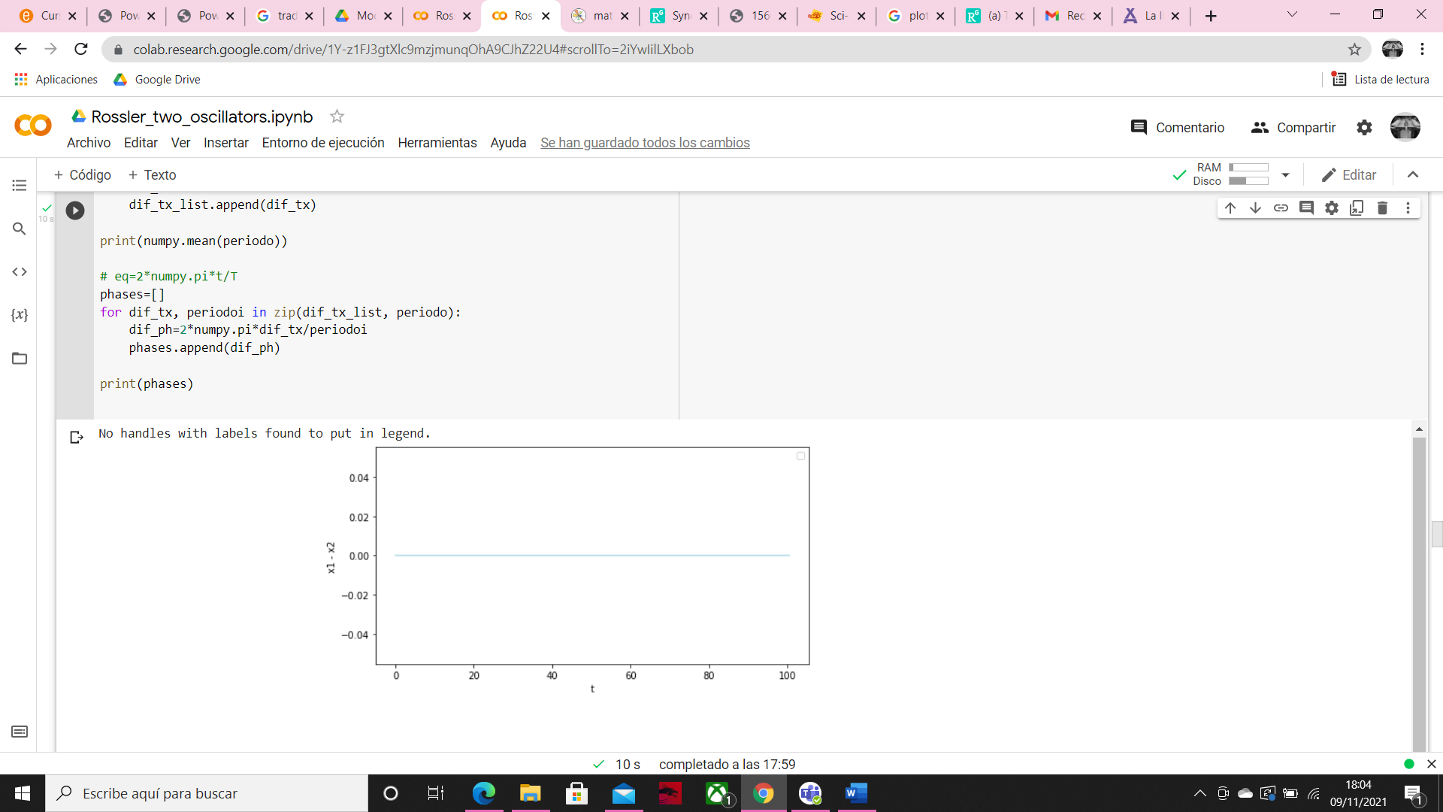

The behavior is the same for both oscillators so the difference between the values x1 and x2 is always 0.

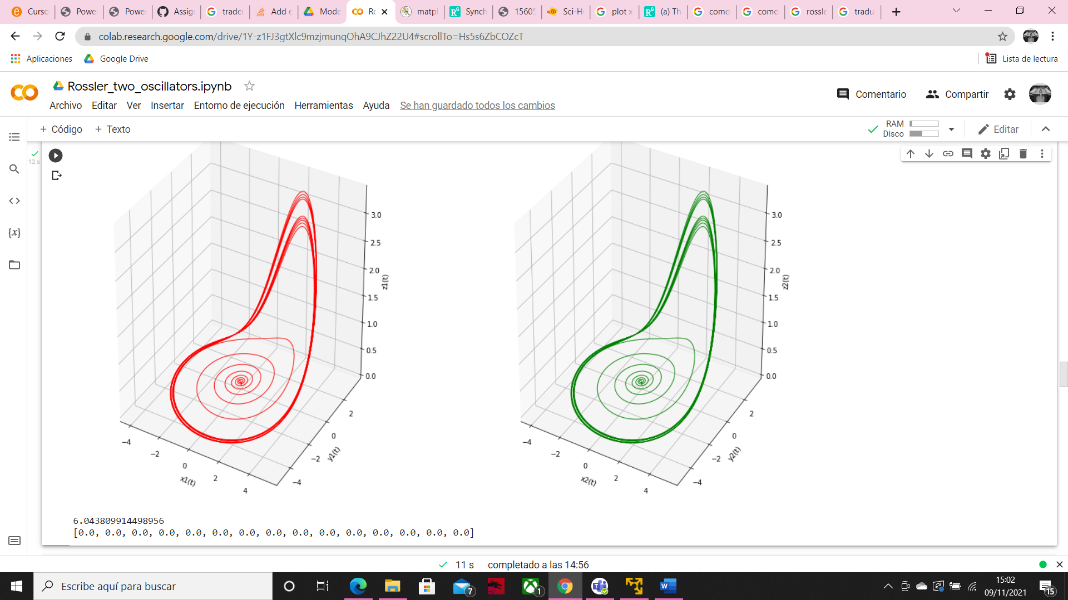

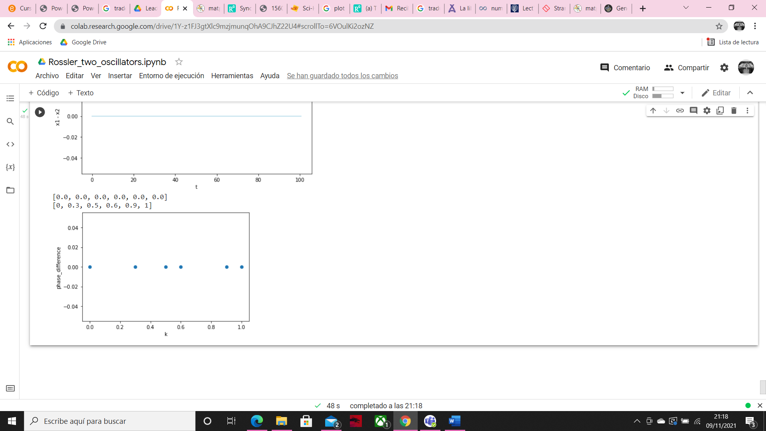

The phase difference is always 0 independently of k.

However, if we start with slightly different initial conditions, we can see how the values of x1 and x2 became more desynchronized over time. In this case I set initial conditions equal 1 to al parameters, except y2 = 1.1.

C=3, K=0.1

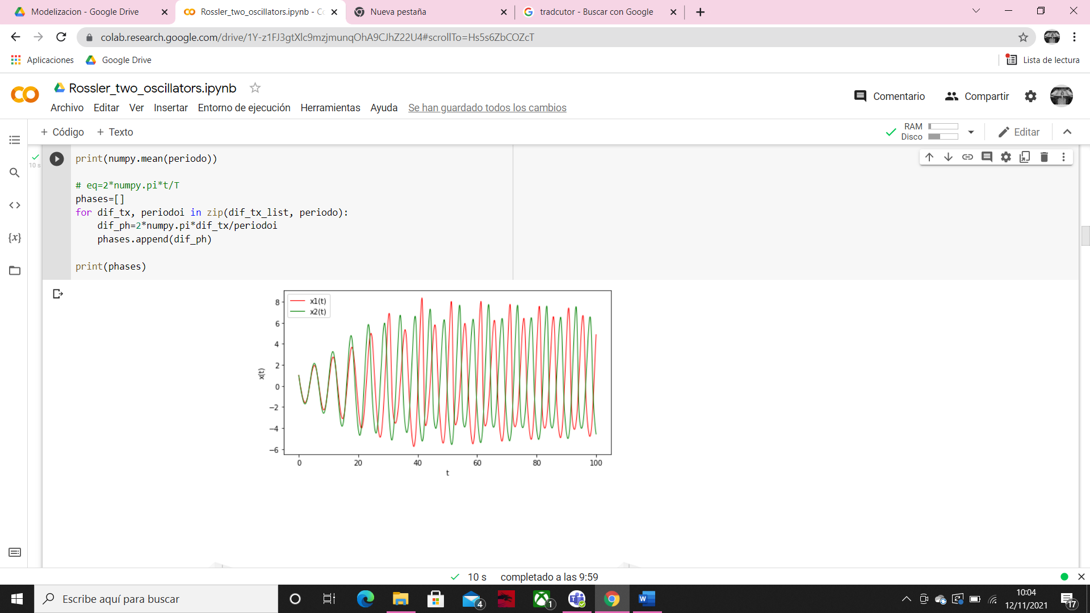

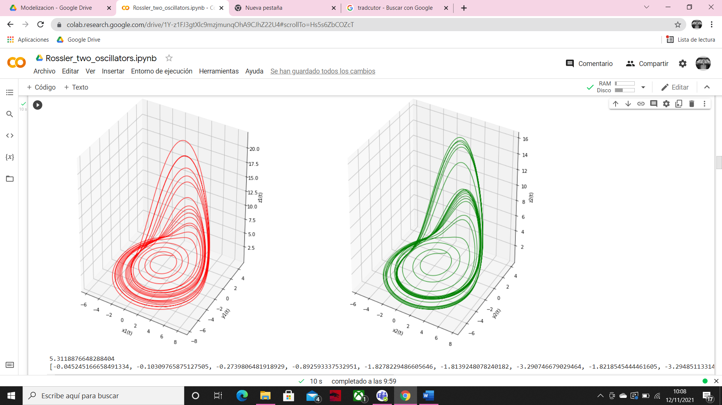

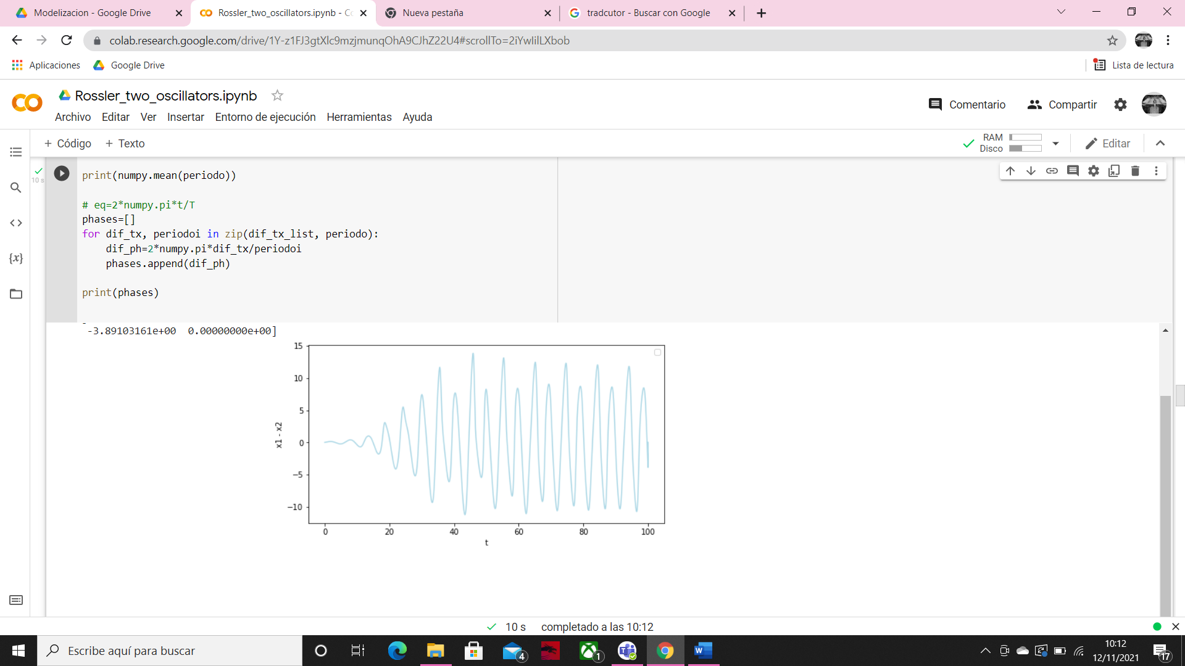

Here we can see the difference between x1 and x2 over time.

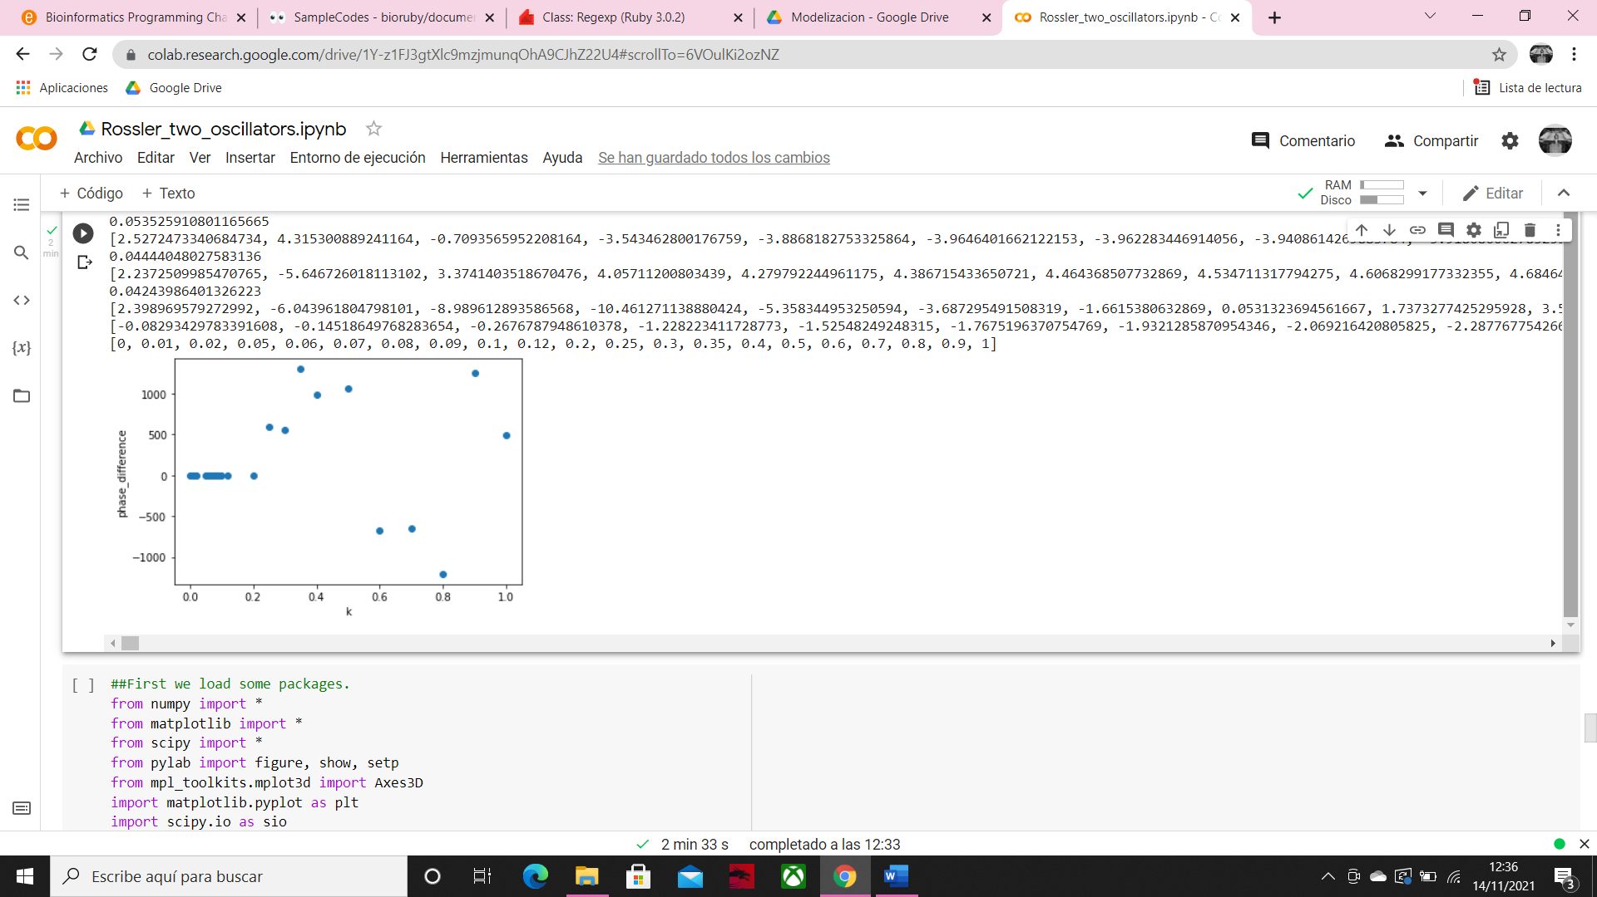

This graph represents how change the Δɸ, considering the mean in each case, respect to different values of K, we obtain Δɸ=0 with k between 0-0.2, so there is full synchronization.

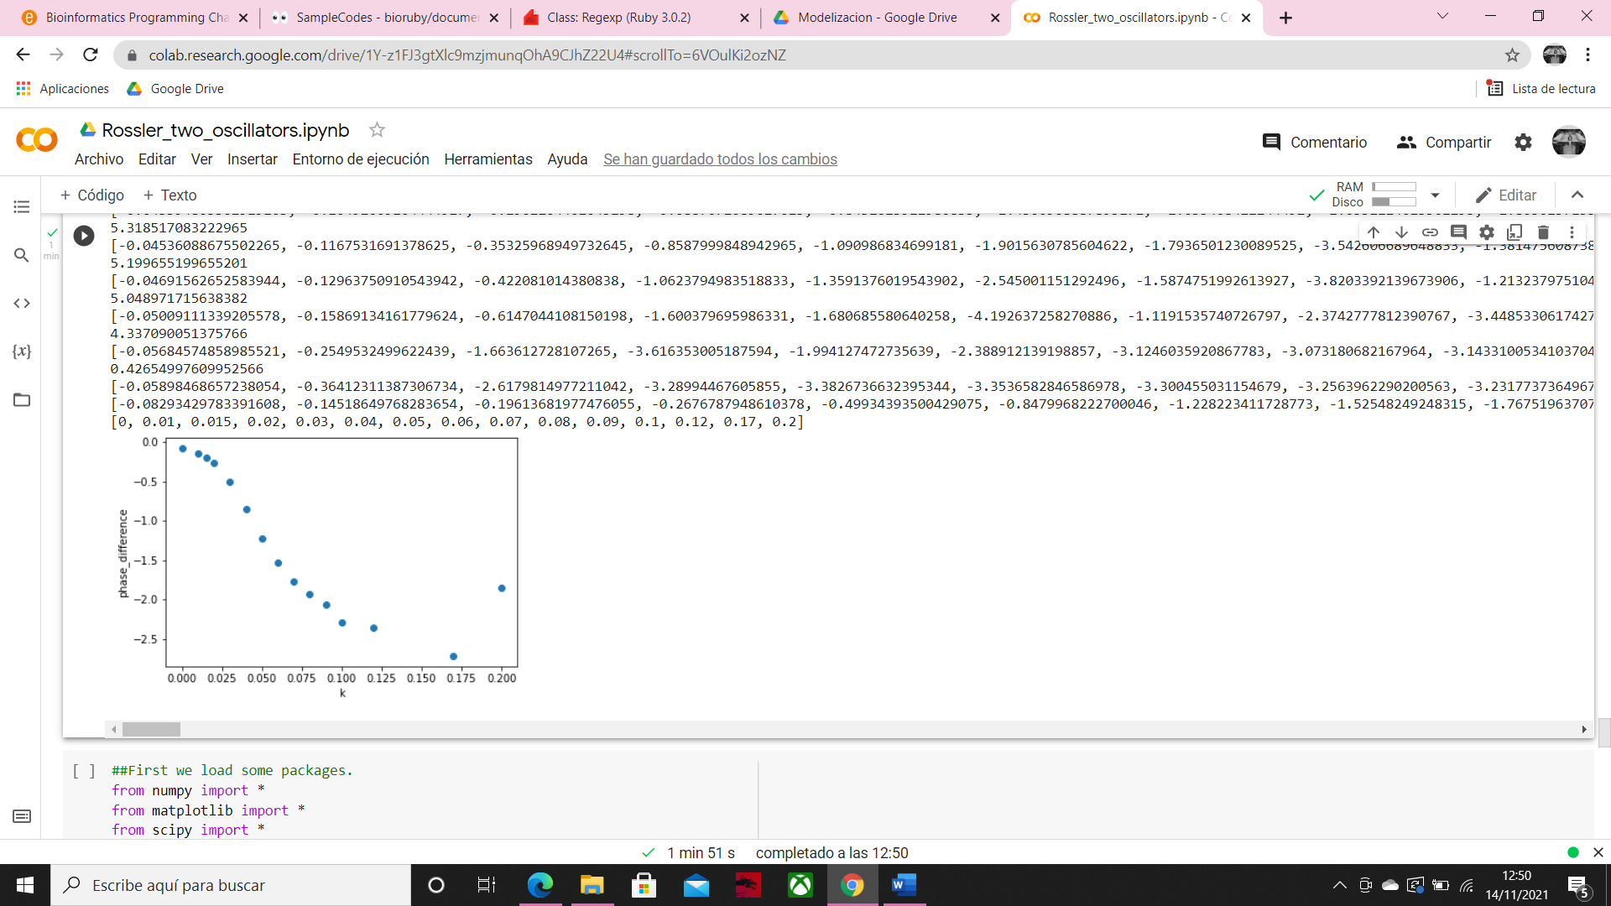

If we repeat the process only in this region of parameters, we can see that there is not a full synchronization, the Δɸ is slightly different increasing K value, in K= 0.2 the difference between phases decreases.

Same parameters, but now we change c=5.2

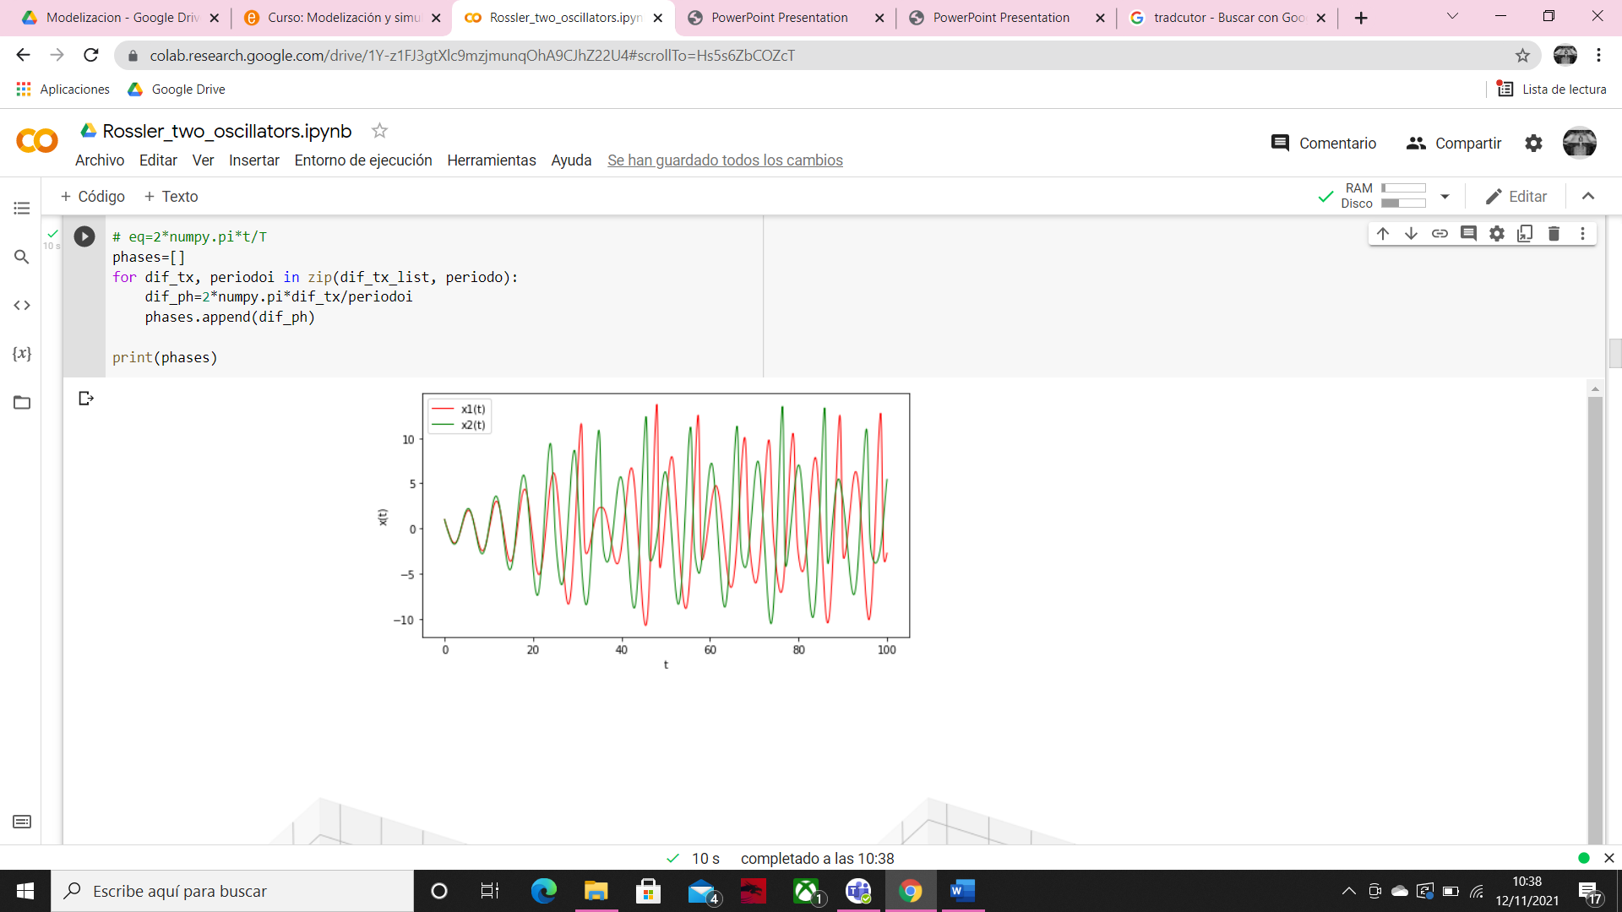

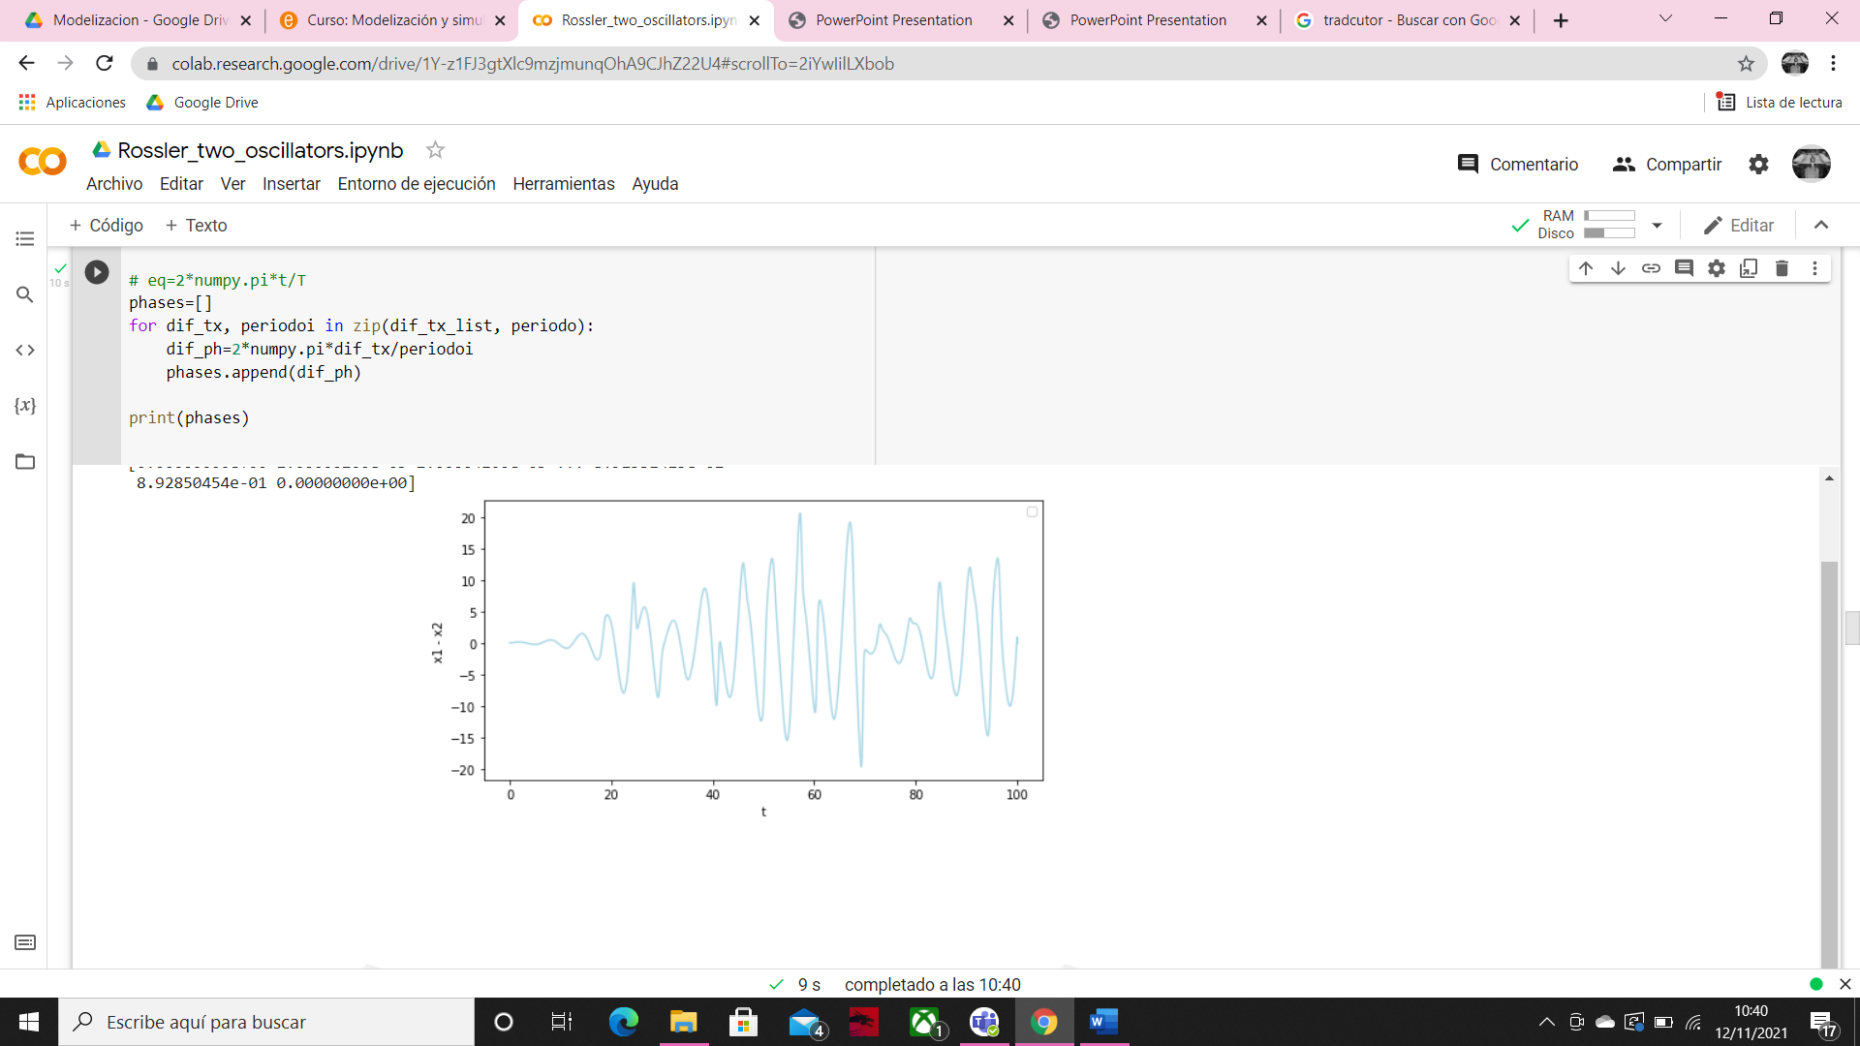

In this case the differences between x1 and x2 is not periodic anymore because we are in the chaotic region.

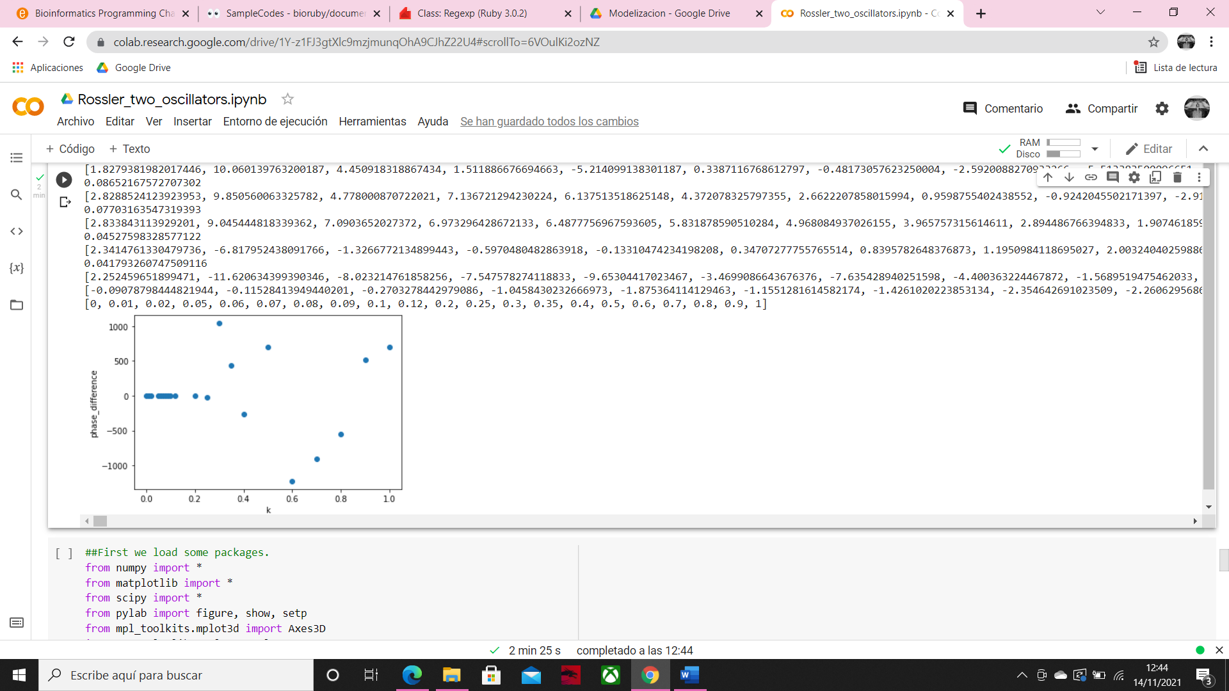

Δɸ take different values but evolve in the same way.

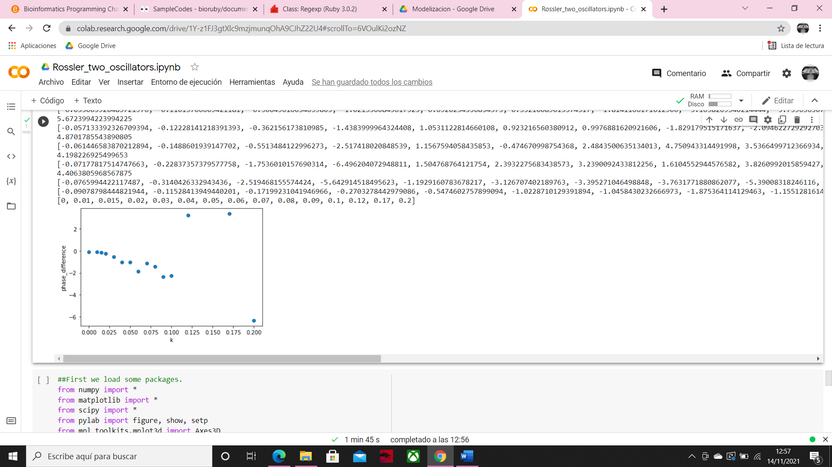

But here we can see that the behavior in this case is different, the Δɸ increase more with the increase of K. Moreover, in K=0.12 we observe how the dynamic diverge.

C=3, K= 0.01

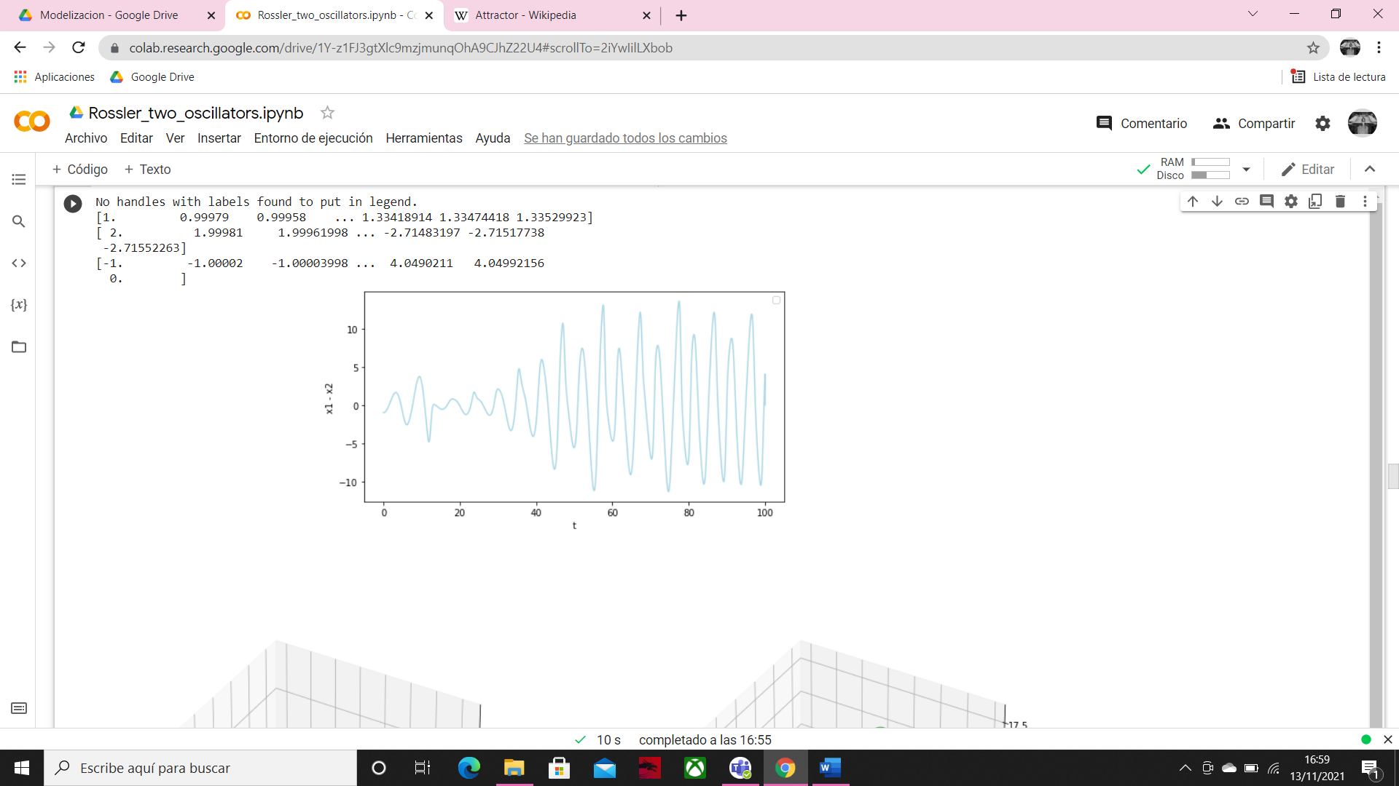

C=3, K= 0.05

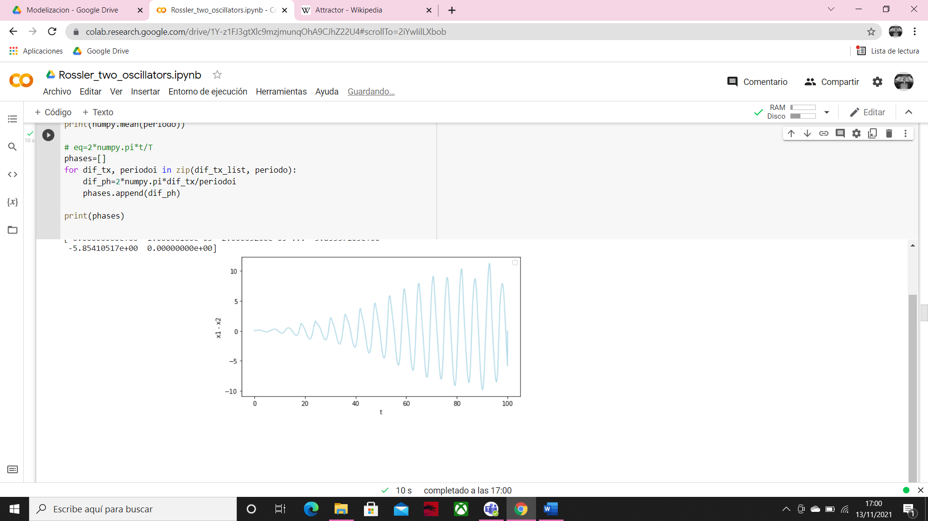

C=3, k = 0.1

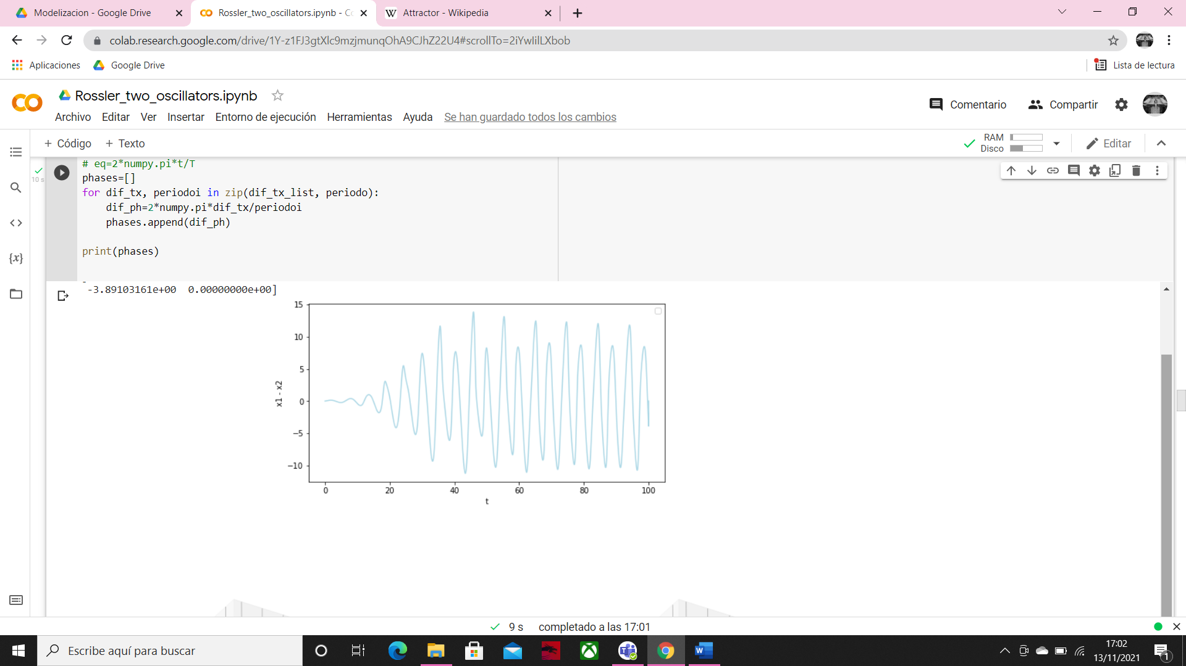

The difference between the values in x1 and x2 is similar in all cases but in the case where K=0.05 it gets more time to have a bigger difference, so it gets more time to increase the time between the intermittent synchronization.

Now we are going to see the behavior if we set the initial conditions with x1=1, x2=2

C=3, k=0.01

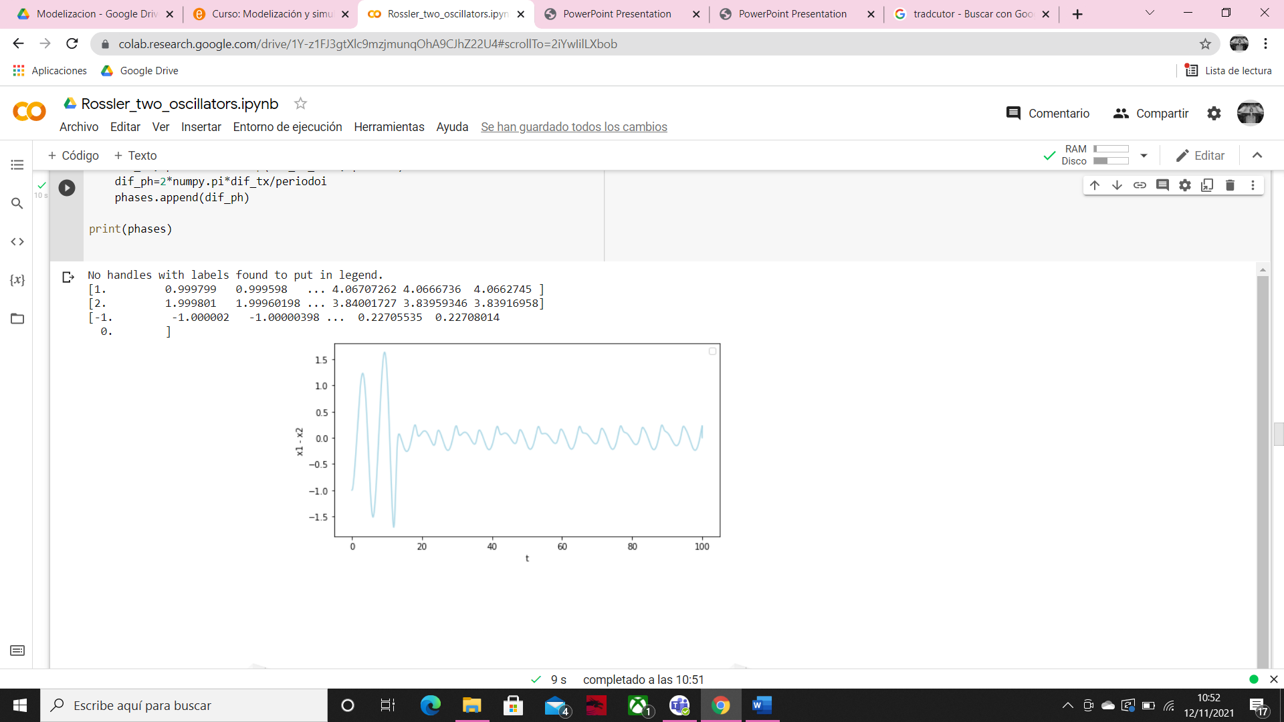

C=3, K=0.05

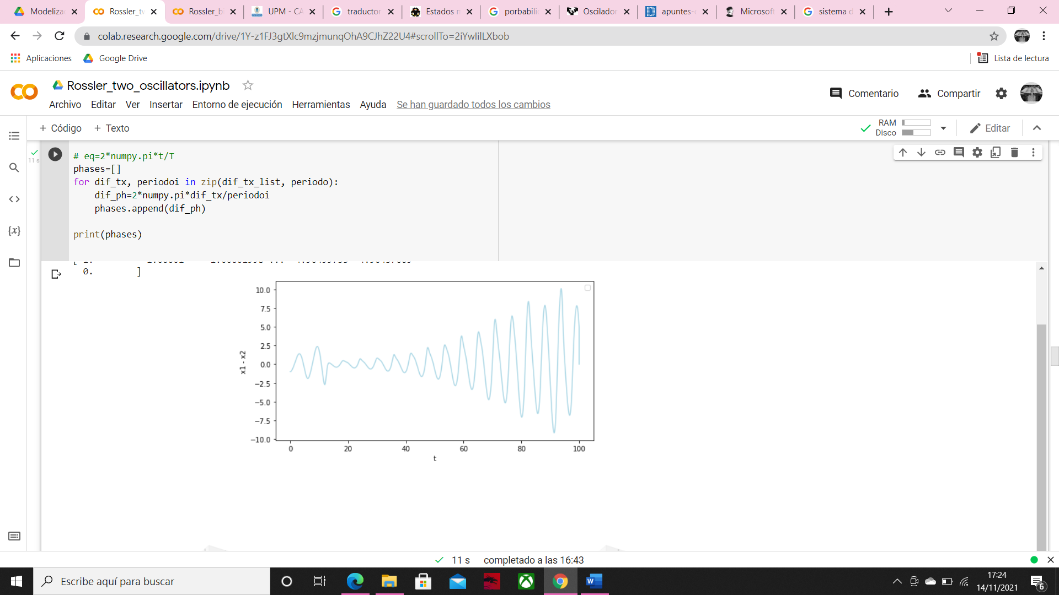

C=3, k=0.1

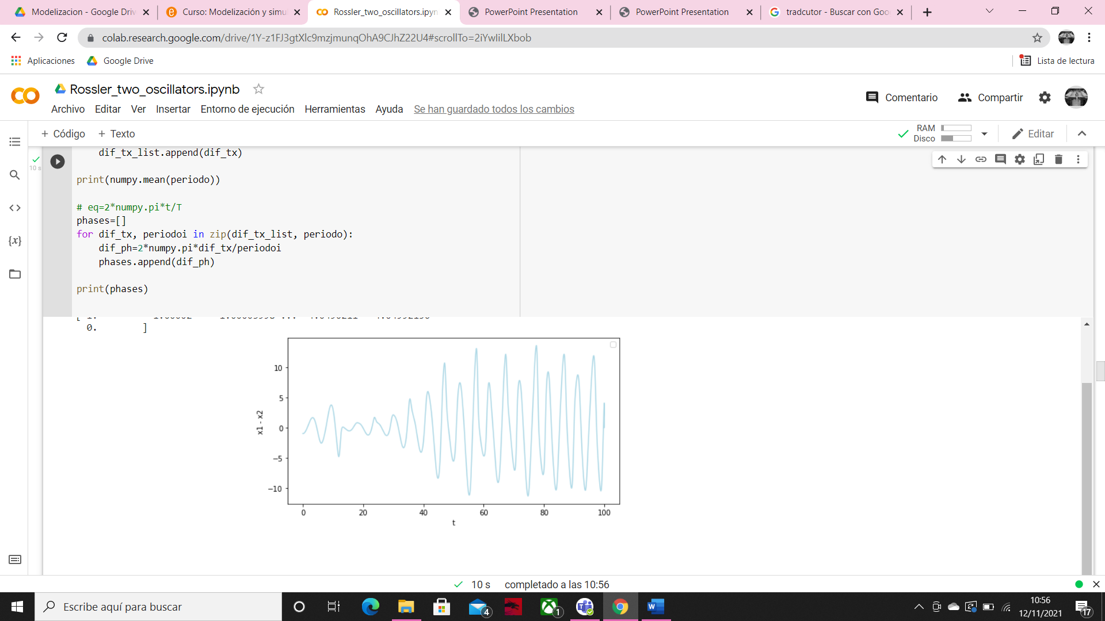

Here we can see how if we set k with a small value, the difference between the values of x1 and x2 decrease over time, using k=0.1 the situation is the opposite, we have some difference irregular values at the beginning, and then the differences increase.

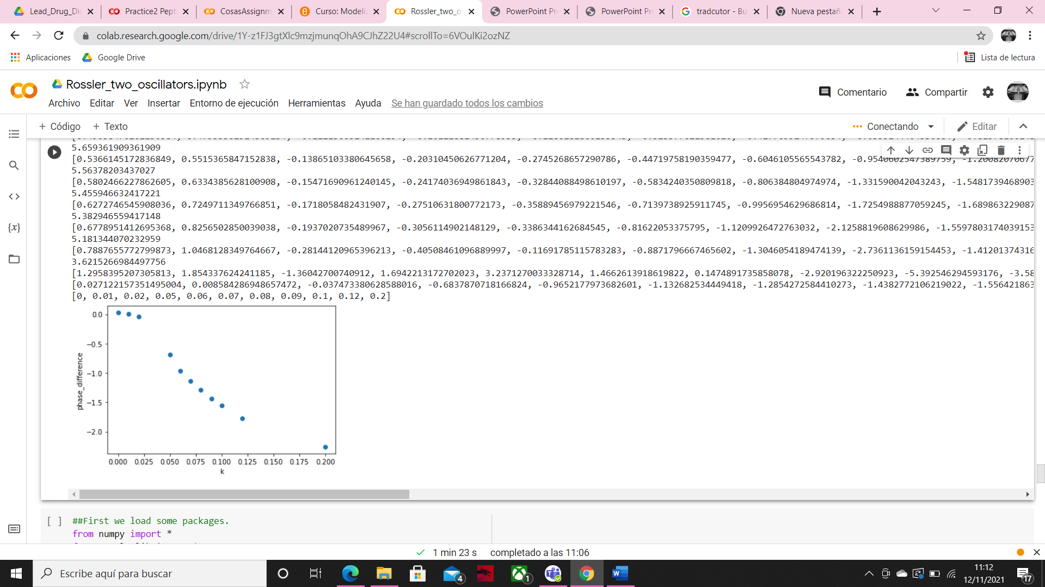

We obtain a similar graph as in the first case. We can concrete that in the moment that we increase K from zero we an intermittent synchronization occurs, when x1 -x2 is close to zero.

**Second situation**

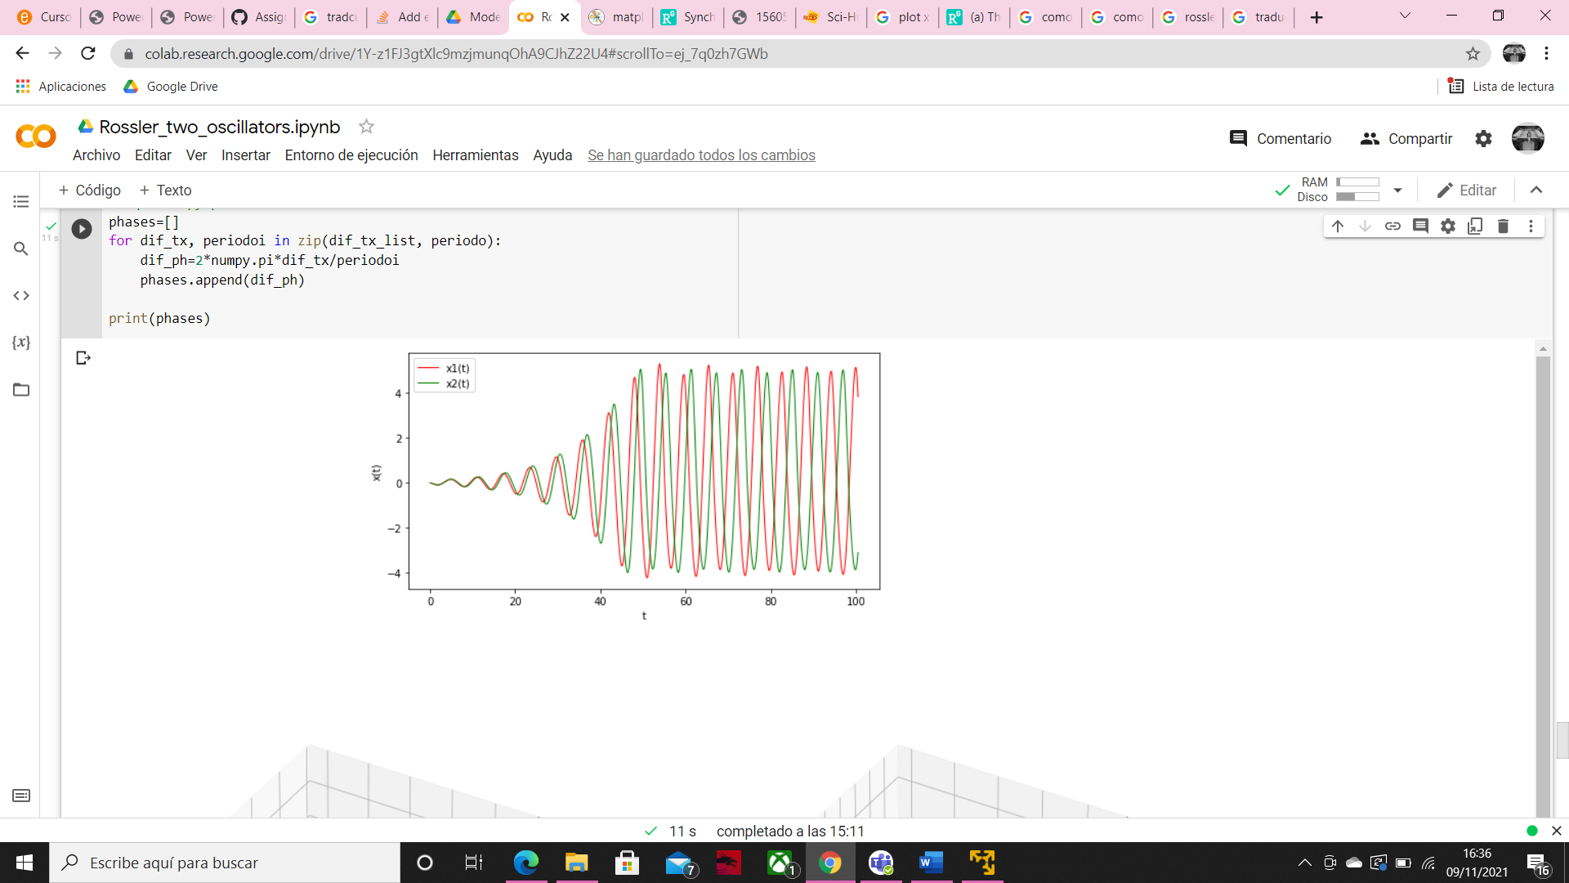C = 3

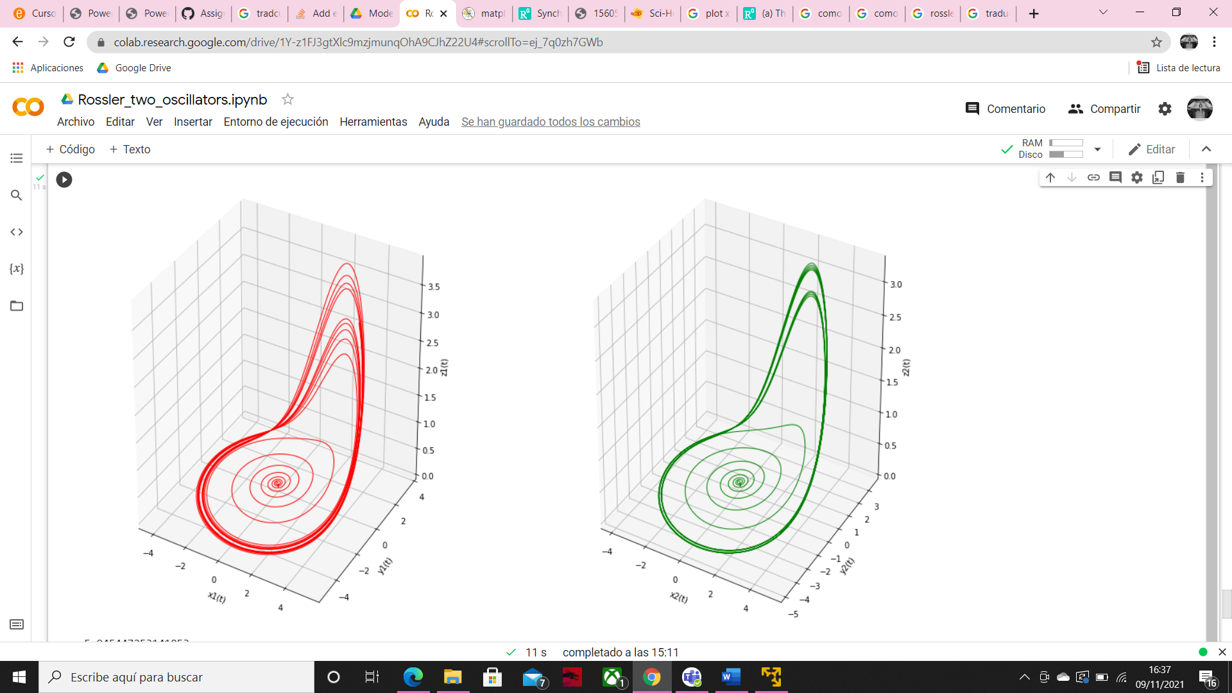

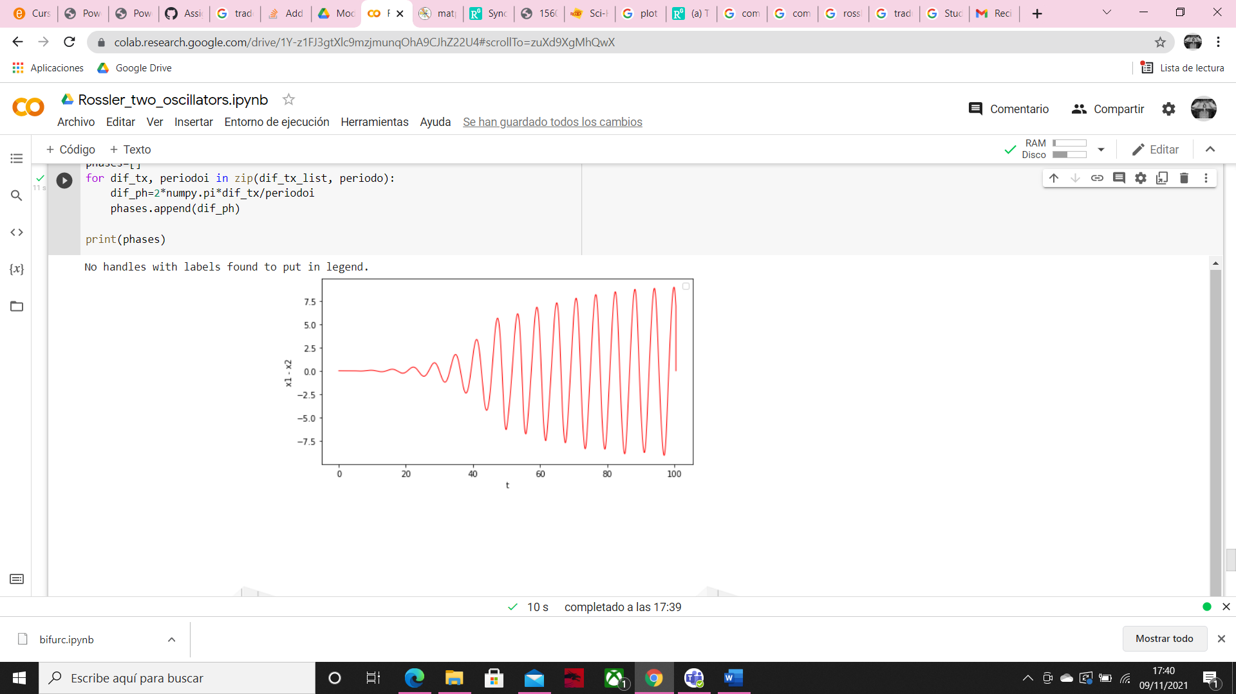

In this case, even if we star with the same conditions (all initial values equal 0) we can see that are differences between the values of x1 and x2 and the difference increase over time too. That’s because with the initial conditions set to zero both oscillator start in the center of the spiral as we can see in the two 3D graphics.

C = 4

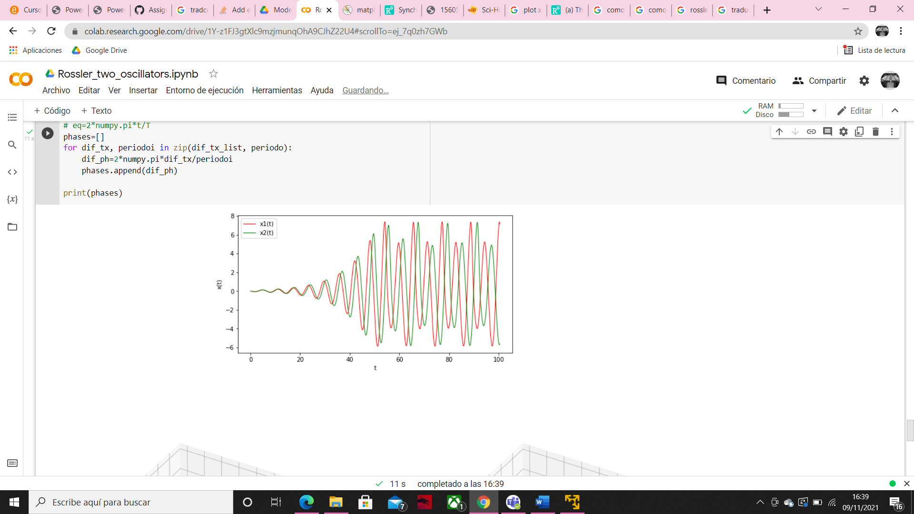

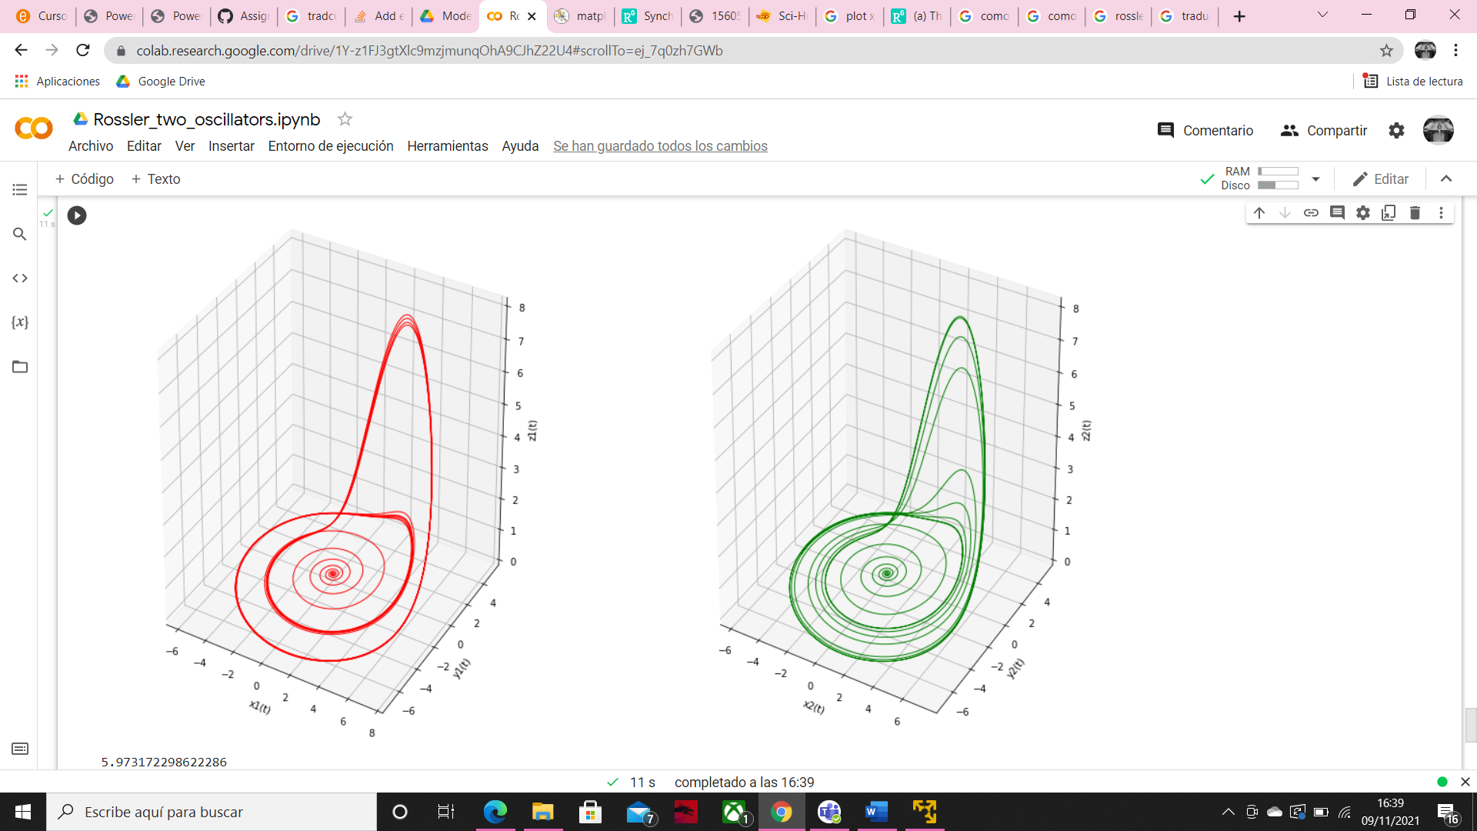

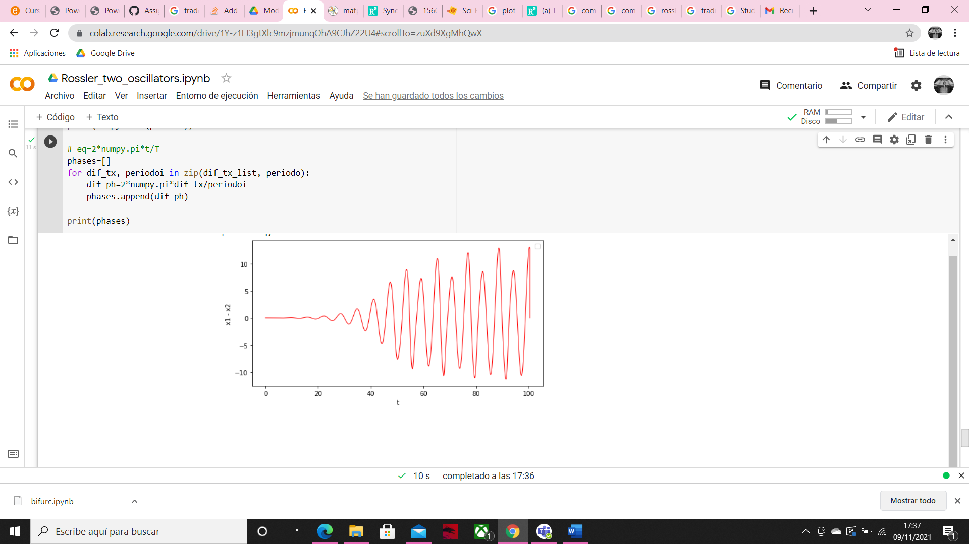

Here we can see how the differences between the two oscillators increases, but the behavior of x1 and x2 is similar at the case above.

C = 5.2

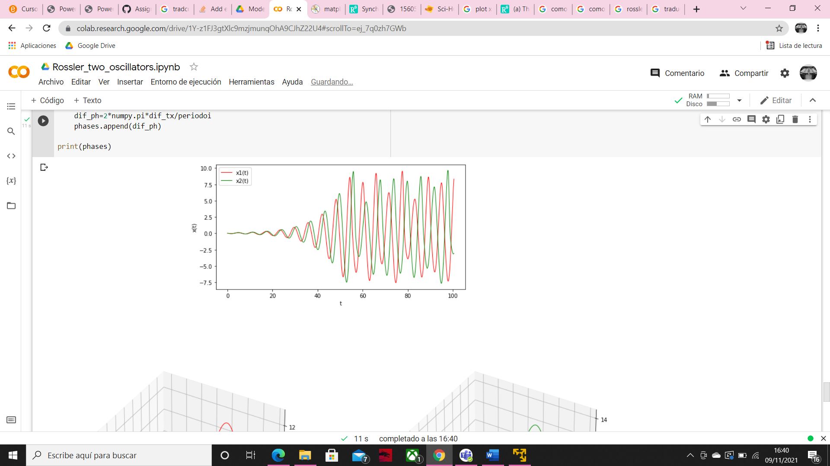

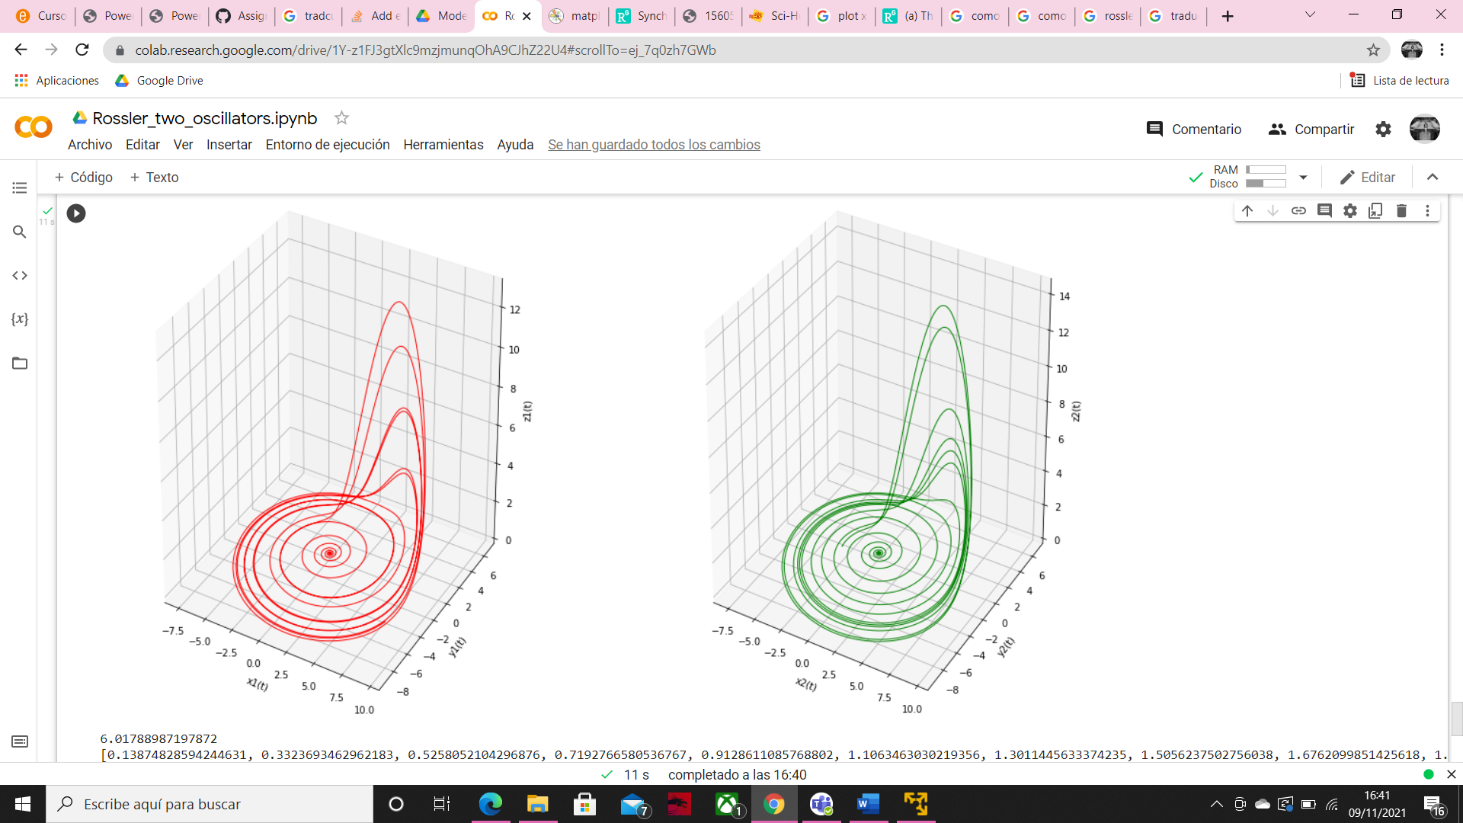

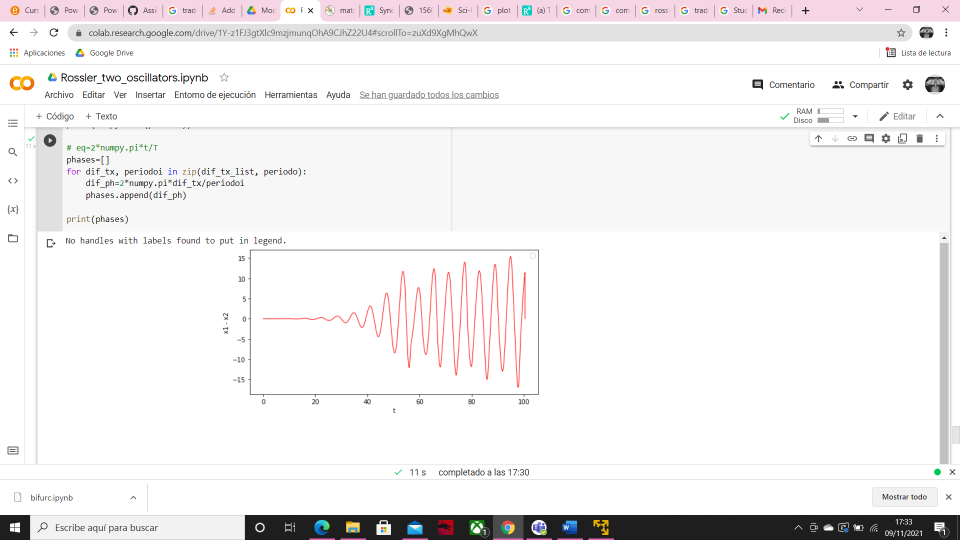

Now the differences between x1 and x2 are a little bit more irregular.

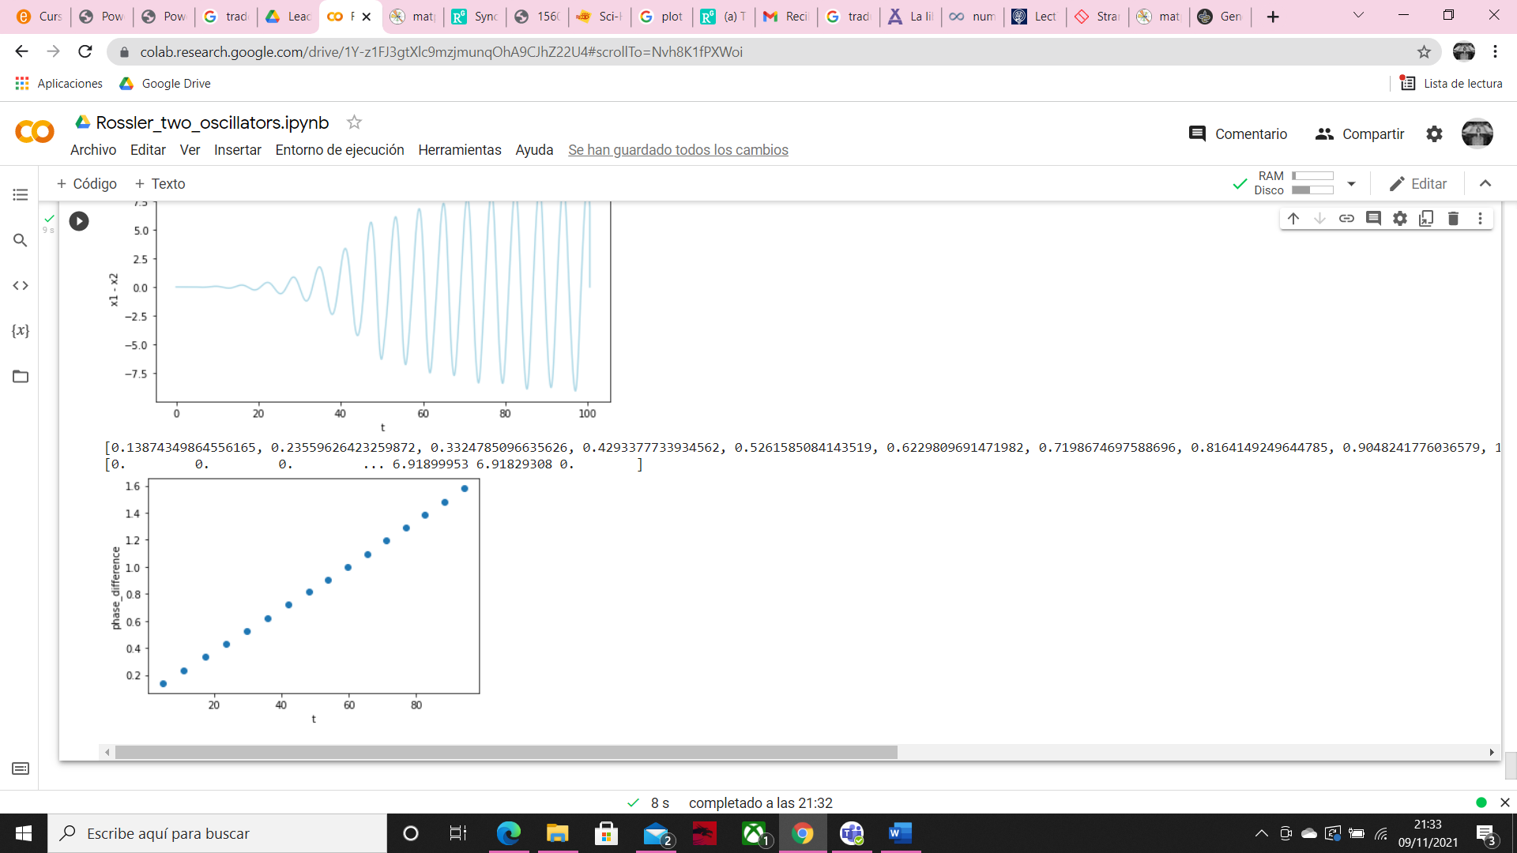

Finally, Δɸ increase linearly over time, as we see in the graphics above.

Regarding the question of where we can find this type of oscillators, we can find it in chemical reactions far from the equilibrium point as R $\ddot{o}$ ssler studied, with those equations:

